Academic Program Approval Voting Record

This document is to be appended as the last page of the proposal for any new or revised academic program to record the successive votes of approval as the proposal moves through its required review and approval steps. Consult Faculty Handbook Section 10.8 or the Faculty Senate Curriculum Committee website for information regarding Committee review and voting requirements for each action.

Curricular Action: (check appropriate boxes below)

1. □ New Program □ Name Change □ Discontinuation □ Concurrent Degree for:
2. □ Undergraduate Major □ Graduate Major □ Undergraduate Minor □ Graduate Minor
□ Undergraduate Certificate □ Graduate Certificate x Other: Combined undergraduate degree and certificate program
3. Name of Proposed Change: ____Graduate Certificate in Biochemistry________________
4. Name of Contact Person: Jack Girton e-mail address: _bpatch@iastate.edu__
5. Primary College: Graduate College Secondary College:
6. Involved Department(s): BBMB

Voting record for this curricular action:

 | Votes
Voting Body | For | Against | Abstain | Date of Vote
Dept. or Program Committee (BBMB) | 20 | 1 | 3 | 12/13/16
LAS Curriculum Committee | 7 | 0 | 0 | 1/20/2017
CALS Curriculum Committee | 14 | 0 | 0 | 1/23/2017
College Approval Vote
- LAS Representative Assembly | 18 | 0 | 0 | 2/28/2017
Graduate College Curriculum Committee
Graduate Council
Graduate Dean

[FSCC – November 2013]
IOWA STATE UNIVERSITY
Roy J. Carver Department of Biochemistry, Biophysics and Molecular Biology
Dr. Jack R. Girton, University Professor
Room 3152 Molecular Biology Building
2437 Pammel Dr.
Ames, Iowa 50011-1079

www.bbmb.iastate.edu
OF SCIENCE AND TECHNOLOGY

Proposal to Establish a Combined undergraduate degree and Graduate Certificate Program

The faculty of the Roy J. Carver Department of Biochemistry, Biophysics and Molecular Biology propose to establish a combined BS and graduate certificate program in Biochemistry. The certificate will be focused in the BBMB department. This proposal is being routed through the appropriate curriculum committees.

Committee/Administrator Date Approval
BBMB Curriculum 12/6/16

BBMB Department
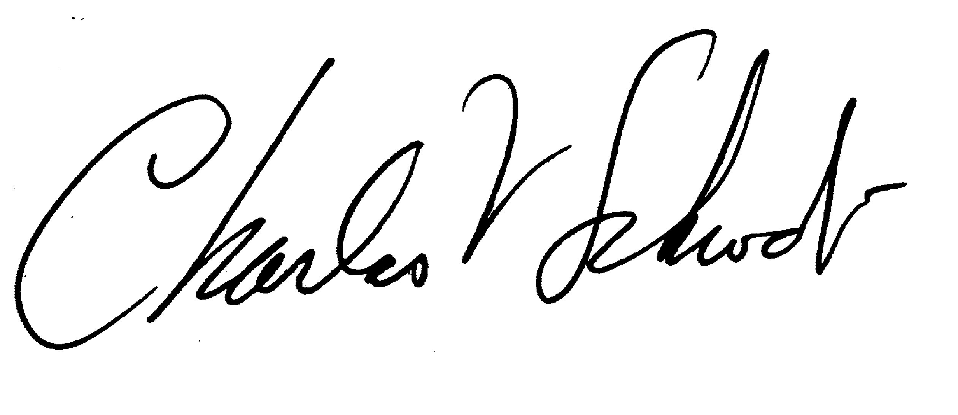

CALS Curriculum 3/1/2017
LAS Curriculum 1/23/2017 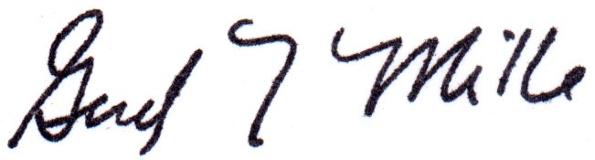

Grad. College Curriculum

Grad Council

Graduate Dean

Proposal for a Concurrent Undergraduate Degree and Graduate Certificate in Biochemistry

The Roy J Carver department of Biochemistry, Biophysics and Molecular Biology is proposing a concurrent undergraduate degree and Graduate Certificate program in Biochemistry.
- Name of the undergraduate program or major and the name of the graduate certificate
BS/Graduate Certificate in Biochemistry
- Name of the undergraduate degree
BS in Biochemistry
- Name of the department(s) which administer(s) the program
The Roy J. Carver Department of Biochemistry, Biophysics and Molecular Biology
- Rationale for the concurrent degree/certificate program
History of concurrent undergraduate/graduate education in BBMB: For nearly three decades BBMB has offered a Concurrent BS/MS degree program that has introduced undergraduate students to graduate studies in biochemistry. The BS/MS program began when professors Robyt and White suggested a five year BS/MS program, which would provide a ¼-time stipend in the senior year, and a ½-time stipend in year five. The program allowed the most motivated and talented undergraduate majors in biochemistry to have a career-boosting early introduction to graduate work in research laboratories. Over the years, many of the undergraduates who entered the BS/MS program stayed on to graduate from ISU with PhDs, and are now tenured professors, research scientists, dentists and physicians. This experience has convinced the BBMB faculty that such combined programs offer a valuable option to students.
Need for and purpose of a concurrent BS/Graduate Certificate program: The financial needs of the undergraduate students are today a formidable problem. Students are pressed to finish their undergraduate program quickly, and that often does not allow talented undergraduates the time to investigate higher level courses or serious laboratory research experience. The consequences are lost opportunities for motivated undergraduate students. The proposed Concurrent BS/Graduate Certificate program is an attempt to recover lost educational opportunities and to allow undergraduate students a chance to demonstrate their commitment to a career in science and gain valuable graduate-level experience within a 4-year program. The concurrent program transitions into a graduate curriculum (see 4-year plan attached). Unlike the BS/MS program, the graduate certificate is given for successful completion of a program of course work, and can be accomplished within the standard in 4 year undergraduate program. The student earns a BS in biochemistry and a Graduate Certificate in Biochemistry after year four, and can transition into a MS or PhD program in biochemistry thereafter. A student completing this program could earn a thesis MS degree in one additional year, or a PhD in three additional years.
- Admission procedures and requirements
Entry requirements and advising under the concurrent BS/Graduate Certificate program: The concurrent BS/Graduate Certificate in biochemistry offers a structured program, with well-defined minimum requirements for consideration. The student must have a GPA of 3.0 by the end of year two. The student must earn a grade of B or better in the core Biochemistry courses: BBMB411, 499, 504, 505, 506, 507, 561, 561L, and 500 level electives. Prior to graduation, the Director of Certificate (DOC) reviews and approves the certificate subject to established practices of the Graduate College.
- Requirements of the program
The requirements of the program are to complete the 12 credits required for the Graduate Certificate in Biochemistry and the 120 credits required for the BS in Biochemistry (a total of 132 credits) with a grade of B or better in the core Biochemistry courses. All course and grade requirements for the BS portion of the program are the same as the existing BS in Biochemistry. No courses taken for the graduate certificate can be double counted for the undergraduate degree requirements. Students taking the BBMB504, 505, 506, and 507 course series will have the undergraduate requirement for BBMB 404 and 405 waived, and will be able to replace these courses with advanced science electives.

A sample 4 year plan for the BS/Certificate in Biochemistry for the College of Liberal Arts and Sciences¹.

BS/Graduate Certificate in Biochemistry
Freshman Year
Fall Total: 15
1 cr. Introduction to Biochemical Activities - BBMB 101
5 Advanced Chemistry – CHEM 201
1 Advanced Chemistry Laboratory - CHEM 201L
4 Calculus I - MATH 165
3 English 150
1 Library Instruction - LIB 160
Spring Total: 16
1 cr. Introductory Biochemistry Laboratory - BBMB 102
4 Quantitative and Environmental Analysis - CHEM 211, CHEM 211L
4 Calculus II - MATH 166
3 Principles of Biology - BIOL 211
1 Principles of Biology Laboratory BIOL 211L¹
3 English 250
Sophomore Year
Fall Total: 17
3 cr. Organic Chemistry I - CHEM 331
2 Laboratory in Organic Chemistry - CHEM 333L
4 Calculus III - MATH 265 (4 cr.) or
Differential Equations - MATH 267 (4 cr.)
3 Principles of Biology II - BIOL 212
5 Classical Physics I - PHYS 221
Spring Total: 18
2 cr. Chemical Principles in Biological Systems - BBMB 201
3 Organic Chemistry II- CHEM 332
2 Laboratory in Organic Chemistry - CHEM 334L
5 Classical Physics II - PHYS 222
3 Area 3 Social sciences²
3 Elective

Junior Year
Fall Total: 16
2 BBMB 504
2 BBMB 505
3 Principles of Genetics– BIOL 313
3 Quantum Mechanics - CHEM 324 (or Area 1 or Area 3)
3 Area 1 Arts and Humanities
3 Area 3 Social Sciences

Spring Total: 17
2 BBMB 506
2 BBMB 507
3 Principles of Cellular Biology - BIOL 314
3 Area 1 Arts and Humanities
3 Area 1 Arts and Humanities
3 Chemical Thermodynamics CHEM 325
1 Stupka Symposium – BBMB 490 or 593

Senior Year
Fall Total: 17
2 BBMB 5XX elective
4 BBMB 411 General Biochemistry Research Techniques³
3 Area 3 Social Sciences
3 Area 1 Arts and Humanities
2 BBMB 499 Undergraduate research
3 Elective

Spring Total: 16
2 BBMB 5XX elective
2 BBMB 561 Molecular Biophysics
2 BBMB 561L Molecular Biophysics Laboratory
3 Elective
4 BBMB 499 undergraduate research
3 Biological Science elective

Footnotes:
¹ One Biology laboratory course is required.
² Liberal Arts and Sciences (LAS) General Education Requirements include a minimum of:
12 cr. Arts and Humanities, 9 cr. Social Sciences. All ISU students must take both a 3 cr. course in U.S. Diversity and a 3 cr. course in International Perspectives, which may be double counted with arts and humanities or social sciences, and have 3 years of same foreign language in high school or 4-8 credits of World Languages
³ Advanced communications requirement (3 credits) is fulfilled by a grade of C or better in BBMB 411.
Total credits for the combined BS/Certificate program is 132: 120 credits are for the BS (black letters). 12 credits for the certificate (red letters). BBMB 561 satisfies the BBMB 461 requirement for a BS in biochemistry. BBMB 561L satisfies the CHEM 322L requirement for a BS in biochemistry.
- Expected enrollment
The BS in Biochemistry currently has more than 180 majors. A high percentage of these majors are interested in graduate education and/or research. We anticipate as many as 10% would be interested in this BS/Certificate program. This would give 10-20 students per year.

- If not already addressed, answer the following:
- How will the undergraduate degree plan and graduate certificate program of study be developed? Answered above
- When will the student have an advisor for the graduate certificate? A faculty advisor will be assigned when the student is admitted to the certificate program (in the 3rd year). This may be the same advisor the student had for the BS program.
- Will graduate assistantships be provided? No
- Who will be responsible for the administration of the program? Answered above
- How much time is required to complete the program? 4 years. Show a sample semester-by-semester plan. A sample plan is presented above.
- Will students be allowed to double count credits (if the certificate requires more than 12 credits)? If so, how many credits? The certificate requires 12 credits, so no double counting will be allowed.
9. Attach memos showing approval by appropriate department and college committees, faculty, and administrators.
List of approvals is included on the first page

10. Proposal Contact
Jack R. Girton, Ph.D. University Professor
Roy J. Carver Department of Biochemistry, Biophysics and Molecular Biology

