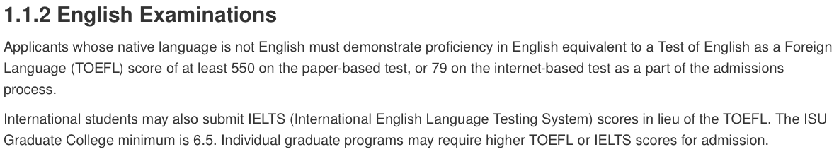
The Dean of the Graduate College may exempt applicants with expired scores above the college minimum from the requirement to demonstrate English proficiency. Exemptions are not considered based on other factors, such as a student’s employment experience, time living in the United States or another country where the use of English is common, and proficiency as judged by faculty, staff, or admissions committees.

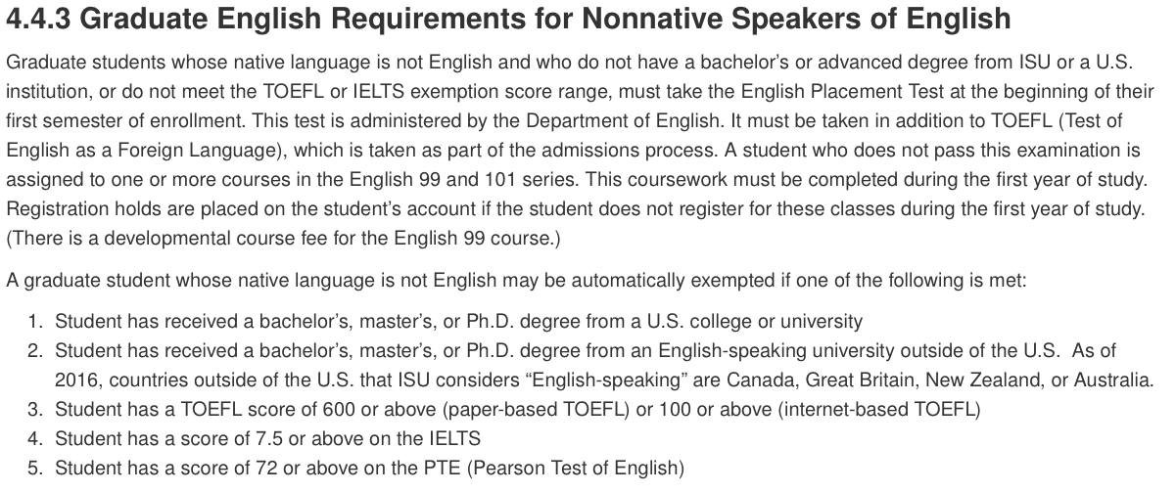
The Dean of the Graduate College may exempt students with qualifying but expired scores on the TOEFL, IELTS, or PTE from the requirement to take the English Placement Test. Exemptions are not considered based on other factors, such as a student’s employment experience, time living in the United States or another country where the use of English is common, and proficiency as judged by faculty, staff, or admissions committees.

