Form A
Board of Regents, State of Iowa

REQUEST TO IMPLEMENT A NEW BACCALAUREATE, MASTERS, DOCTORAL, OR FIRST PROFESSIONAL DEGREE PROGRAM

REVISED 9/25/18

Institution: Iowa State University

CIP Discipline Specialty Title: Meeting and Event Planning

CIP Discipline Specialty Number (six digits): 52.907

Level: Masters

Title of Proposed Program: Event Management (EM)

Degree Abbreviation: M.S.

Approximate date to establish degree: August, 2018

Contact person: Eric D. Olson, Ph.D., Program Director, Event Management, 515-294-0699, olsoned@iastate.edu; Eulanda A. Sanders, Ph.D., Department Chair, Ph.D.; Professor and Donna R. Danielson Professor in Textiles & Clothing, 515-294-7474, sanderse@iastate.edu

College that will administer new program: College of Human Sciences (CHS); Department of Apparel, Events, and Hospitality Management (AESHM)

College that will administer new program: Human Sciences

Please provide the following information:

1. Describe the proposed new degree program, including the following:

a. A brief description of the program. If this is currently being offered as a track, provide justification for a standalone program.

The proposed Masters in EM consists of 36 credits, including 13 credits distributed over five required classes; six credits from EM electives, six credits from Hospitality Management courses, five-six credits from courses from other departments, three credits from Research Methods, and three/four credits from statistics courses. The creative component course will provide an opportunity for students to apply EM concepts to an industry-related project. The proposed program will be delivered online. Appendix A provides a program of study example, Appendix B provides a sample of a two-year plan, and Appendix C states descriptions of courses.
It is anticipated that students will be recruited from the following four sources including: (1) current employees in Iowa with a Bachelors degree from an accredited university that have an EM focus in their employment responsibilities, but no formal education in event planning; (2) members from professional associations in meeting and event planning such as Professional Meeting and Convention Association (PCMA) and Meetings Professional International (MPI) and have a Bachelors degree from an accredited university; (3) international students seeking a Masters degree in Event Management; and (4) alumni of ISU Event Management undergraduate program.

Targeted individuals have responsibilities that are part of mid- and executive-level of event organizations or are event entrepreneurs that have an undergraduate degree in EM, hospitality management, or another related field. Examples of roles and position titles where graduate education in EM would be required include: Director of Meetings, Association Meeting Planners, Director of Sales, Executive Corporate Meeting Planners, and City Economic Officers. Furthermore, event and meeting planners work in a variety of sectors such as corporations, associations, government agencies, non-profit organizations, mega events (e.g., Olympics and Super Bowl), fairs/festivals, sports events, and independent businesses/consultants. These roles and position titles often require a graduate degree, and this proposed degree will provide graduates with EM knowledge for leadership roles in the EM industry. Benefits of obtaining a Masters in Event Management include greater employment opportunities, professional development, networking opportunities, and greater recognition and credibility.

b. A statement of academic objectives:

The program will be designed utilizing guidelines and recommendations of the Meeting and Business Event Competency Standards Curriculum Guide, a governing body that oversees event management curriculum. Upon successful completion of the Masters degree program in EM, students will be able to:

a) create meeting and event plans based on research and analysis, trends, goals and objectives, larger organizational plans and financial resources; work within economic and social realities; and work within unique conditions in highly complex and unpredictable environments;

b) analyze event and meeting risks and develop comprehensive risk management and emergency response plans to cover unpredictable and complex situations;

c) design and build a range of revenue streams and manage financial processes and pricing;

d) create and monitor human resource plans to achieve event and organizational goals, build teams, and develop training and development plans for staff, volunteers, and other stakeholders;

e) design program components and delivery formats and determine functional requirements;

f) manage meeting and event site(s) by completing site inspections and selecting the best option(s); create site layouts/floor plans; develop the logistics plan; monitor the set-up, take-down and running of the event; and establish onsite communication protocol;

g) integrate multidisciplinary social science theories to explain contemporary event management challenges and opportunities;

h) engage in critical thinking, accept new models/paradigms, examine similarities and analogies, and recognize new priorities in the event management domain;

- understand the ethical, legal, societal, and economic concerns of event management; and

j) visualize, interpret, and communicate event management concepts to a variety of stakeholders.

This proposed program will utilize expertise and experience of existing AESHM department faculty members. EM graduate faculty have a combined 18 years of teaching in higher education; produce scholarly activities in areas of event sustainability, event social media, festival and events, and event tourism; and possess professional experience in events while working with organizations such as the Walt Disney Company, international governments (e.g., Aruba, Japan), and nonprofit organizations (e.g., Abe Foundation).

b. What is the need for the program is and how the need for the program was determined:

The events and meetings industry is a global phenomenon, and the meetings industry generates more than $263 billion in direct spending and $907 billion in total industry output. A variety of stakeholders—government, corporations, associations, non-profits, and individuals—use events for a variety of reasons. For example, governments utilize events to stimulate local economics and provide leisure activities for residents. Corporations use events for internal reasons, such as training and incentives, as well as using events to increase shareholder wealth. Associations use events to provide education, training, networking, and other opportunities for association members. Non-profits use events as a source of fundraising and organization awareness. Individuals use events as a source of entertainment, to connect with others, and to enhance quality of life.

Negative consequences can occur for individuals, families, and communities when events are planned and operated erroneously. Due to improper stage setup, an outdoor stage collapsed at the 2011 Indiana State Fair, killing seven people. The recent shootings at the Route 91 Harvest country music festival in Las Vegas in October 2017 have perpetuated the need for managers to be familiar with the complexities of event planning and risk management. Graduates of our program will be aware of the operational and ethical dimensions of executing a risk management, security, and emergency response plan for events.

Events, such as street festivals, community events, music, and sports events, have the power to enhance a community’s well-being. However, accessibility to events—physically, economically, and socially—continue to challenge event managers. Venues continue to be critiqued for accessibility challenges for attendees with disabilities, despite The Americans with Disabilities Act of 1992 and the Architectural Barriers Act of 1968. Furthermore, events have been criticized for adding to the economic disparity debate between the “haves” and the “have nots” of being able to afford attending special events, such as sporting, music, and destination events. Graduates of our program will become aware of these event challenges and mitigate actions to ensure events are accessible for all.

This proposed online graduate program is possible because of the growing EM program, started in 2011, and the program is part of the Department of Apparel, Events, and Hospitality Management (AESHM) in the College of Human Sciences. Furthermore, there are only a handful of Masters programs in EM in the world, and this program will be one of the first graduate programs in EM in the United States and the world.

This proposed program is warranted for three main reasons:

- The continued growth and expansion of global events, meetings, sport events, and festivals as well as the expansion of the entertainment industry has called for increased EM professionals. Employment for meeting, convention, and event planners is expected to increase by 10% in the decade 2014 to 2024, which is faster than the average for all occupations, according to the United States Department of Labor (2017). Additional trends in the event industry include the experience economy/co-creation of experiences, commodification of event experiences, and the increase use of virtual events (Getz & Page, 2016).

- Our Bachelor of Science in EM undergraduate degree started in 2011, and 426 students have graduated from our program. Additionally, there are currently over 369 EM majors enrolled in the undergraduate program, and approximately 72 EM minors in our program. Our alumni work in a variety of roles throughout the state of Iowa, and the Department receives inquiries about the creation of a Masters in Event Management on a frequent basis. Ninety-two percent of our EM bachelors’ graduates have employment or are pursuing additional education within six months of graduation.

- Students who require a flexible program will be interested in our program because our program will be administered completely online. The flexibility of our program will fit the needs and wants of students and professionals who are currently balancing employment, family, and other needs. Furthermore, the proposed program will provide access to all, including those that cannot travel, live elsewhere, and find it difficult to access campus (e.g., students with disabilities/physical impairments).

d. The relationship of the proposed new program to the institutional mission and how the program fits into the institution’s and college’s strategic plan.

The proposed Masters in EM aligns with the ISU mission to “create, share and apply knowledge to make Iowa and the world a better place” by providing event managers with knowledge to make stronger EM strategic and managerial decisions. This program supports ISU 2017-2022 Strategic Plan Goal 1 of “ensuring access to the ISU Experience” by providing an exceptional event management education that provides “practical, global, and leadership experiences and informed critical thinkers needed to solve 21st century” event management challenges. The proposed program also supports ISU 2017-2022 Strategic Plan Goal 3 “improve the quality of life for all Iowans through services and programs dedicated to economic development” since research has shown that events not only add value to communities through identity, leisure, and a positive place to live and work, but economic benefits as well, such as employment, taxes, and increased tourism.

The proposed Masters in EM supports the AESHM department mission and EM program mission of “being leaders in undergraduate and graduate education in the areas of event management and planning” by sharing and applying knowledge to improve people’s lives by meeting the needs of families, communities, schools, nonprofit organizations, entrepreneurs, and businesses. Furthermore, this program will ensure student access to an exceptional education in the area of EM. By educating current and future event managers and planners, this program will improve the quality of life for Iowans as graduates of this program will have a firm understanding of the importance of events to businesses and communities.

e. The relationship of the proposed new program to other existing programs at the institution; describe how the proposed program will enhance other programs at the university. Will the proposed program duplicate existing programs at the university?

The proposed program will provide coursework at the graduate level and will complement the current undergraduate EM degree at Iowa State University.

The proposed program curriculum requires courses to be selected in HSP M, AESHM, and other programs, such as graduate courses in the Greenlee School of Journalism and Communications and College of Design. The proposed program consists of six credits from graduate-level courses in HSP M, six credits from courses offered by other departments (e.g., business, design, public relations) and research methods/statistics courses offered in the STAT, RES EV, and AESHM departments.

While elements of EM skills are similar to hospitality management and business skills (i.e., financial management), the proposed program differs from the current HSP M masters program since unique skills are required for event managers (e.g., site selection, event design, event risk management and event emergency response, and event project management), and these skills are not deliberated in other graduate curriculum.

f. The relationship of the proposed new program to existing programs at other colleges and universities in Iowa, including how the proposed program is different or has a different emphasis than the existing program.

A search of the following websites: Iowa Board of Regents, Iowa Department of Education, The University of Iowa, and University of Northern Iowa did not reveal any current existing masters program in EM. Currently, The University of Iowa only offers an undergraduate certification in event planning (https://clas.uiowa.edu/sjmc/undergraduate-programs/certificates/event-planning-certificate) that is part of the School of Journalism and Mass Communication. We have reached out to the Program Director of Event Management at The University of Iowa, and we have received a letter of full support (please see Appendix D). No other university in Iowa offers a masters degree in EM.

f. Special features or conditions that make the institution a desirable, unique, or appropriate place to initiate such a degree program.

The AESHM department has a long history and culture of producing and executing a wide variety of events, such as the Fashion Show, the Cherry Pie fundraiser (in conjunction with the Joan Bice Underwood Tearoom), and Fine Dining events (HSP M 487/587). The undergraduate program in EM was a natural extension of students participating in these events to formalize an event management program because many AESHM students actively took leadership roles in the planning and executing of department, college, and university events.

Current faculty and graduate students in the AESHM programs conduct research in the event, meeting, and festival realms such as The Iowa State Fair, mega events, Pride festivals, community-based festivals, and EM scholarship of teaching and learning. AESHM faculty are recognized as faculty that lead cutting-edge research and publish in top-tiered EM, hospitality, tourism, business, apparel, and design journals and present at leading conferences throughout the world. The increase of faculty with experience, teaching, and research capabilities in EM has perpetuated the ISU EM program as a national-leading program. The AESHM department is also a leader in international EM education experiences, such as the creation of Exploring Hospitality and Event Management in the Arabic World program (United Arab Emirates) and the Experience Prague, Czech Republic the Awesome (AESHM) Way. Because of the combination of hospitality and apparel graduate programs in the same department, AESHM has the experience and the ability to execute this proposed program.

The AESHM department provides interdisciplinary teaching and research opportunities in labs for graduate students and faculty, such as the new EM Learning Lab (THE MEETING ROOM: Where Experiences and Technology Innovate), the Joan Bice Underwood Tearoom, and the Digital Apparel and Textiles Studio. Furthermore, our department will be leading efforts for the proposed café and merchandise location at the upcoming Student Innovation Center.

In addition to being one of the first programs of its kind, this program will help shape the discipline by setting the standard for graduate curriculum, and we hope to lead the efforts in creating an accreditation program/commission for EM programs worldwide.

Lastly, CHS’s focus on human potential will make ISU the best university in the world to host an online Event Management Masters degree because our focus is to help people and event managers expand their potential. CHS studies every aspect of people’s daily lives, such as why people attend events, how events can be more sustainable, and how events can be used to make a more equitable society.

Since events are used in numerous disciplines such as hotels, restaurants, theme parks, fashion shows, and retail events, potential teaching and research collaboration exist within the AESHM department. Scholars in the AESHM department could collaborate with the proposed program to provide expertise in the area of design (e.g., EM uniforms, entertainment costumes, volunteer appearance guidelines); the creation of tangible products and services for events (e.g., merchandise, branded product, and visual merchandising); and food and beverage (e.g., food safety, restaurant operations, and nutrition).

h. Are the university’s personnel, facilities, and equipment adequate to establish and maintain a high quality program?

The AESHM department currently has 25 graduate faculty members, with three tenure-track faculty members in the EM program. Furthermore, two graduate level courses in EM have been created and will be used for the proposed program. Current faculty members have the experience to teach graduate EM courses. The new EM Learning Lab (THE MEETING ROOM: Where Experiences and Technology Innovate), created in Fall 2017, will facilitate the delivery of the proposed program by offering space devoted to the program. The AESHM graduate faculty members will be able to assist with teaching of graduate courses (Appendix A) as well as assisting with EVENT 599 Creative Component in Event Management. Furthermore, our department has an administrative assistant in the main office that is completely devoted to our graduate programs. This position facilities the admission process for graduate programs, provides guidance for our graduate students, and assists with all graduate deadlines/paperwork.
i. How does student demand for the proposed program justify its development?

Enrollment in the EM undergraduate program has increased steadily in the last 7 years, peaking at 369 EM majors in 2017. The department receives several inquiries about graduate EM education every month.

Additionally, national- and global-demand for event managers is growing, while only a few educational institutions in the world currently offering graduate courses or certifications in event management. Competitors are as follows:

University | Location | Degree | Format | Number of Students
George Washington University | Washington, D.C. | Graduate concentration only | Face-to-face | 8
Hong Kong Polytechnic | Hong Kong | Master of Science in International Tourism & Convention Management | Face-to-face | NA
Indiana University Purdue University Indianapolis | Indianapolis, Indiana | Master of Science in Event Tourism/Sports Event Tourism | Face-to-face | 10
San Diego University | San Diego, California | Meeting and Event Management | Hybrid | Launch 2019
University of Brighton | Brighton, United Kingdom | Master of Science International Event Management | Face-to-face | NA

We will be one of a few programs offering a Masters degree in EM in the country and the world.

2. Describe the state and/or national workforce needed and/or demand for graduates of the proposed program currently and in the foreseeable future (provide document about sources of data used to estimate the need and demand).

According to the U.S. Department of Labor, Bureau of Labor Statistics, demand for event managers is expected to grow 10% in the decade 2014-2024, which is faster than the average of all occupations. Formalized undergraduate EM degrees have only been offered by universities in the past decade. In industry and practice, many professionals “stumble” upon EM responsibilities as part of their overall job responsibilities in areas of marketing, administration, public relations, and sales. Typical entry-level education required for meeting, convention, and event planners is a bachelor’s degree, and 2017 median pay was $47,350 per year.

In recent years, additional EM undergraduate programs have started, such as Metropolitan State University in Denver. The growth in undergraduate programs indicates a natural evolution of the need for graduate education specifically for the discipline. Whereas traditional EM programs evolved from hospitality and tourism programs, scholars and researchers suggest EM should be a stand along program due to increased global growth of events and specific competencies needed for event managers (e.g., site selection, event design, stakeholder development, event risk management, and virtual meetings).

3. List all other public and private institutions of higher education in Iowa currently operating programs similar to the proposed new degree program.

No other masters program in graduate EM exists at the other Regents institutions.

If the same or similar program exists at another public or private institution of higher education in Iowa respond to the following questions:

a. Could the other institution reasonable accommodate the need for the new program through expansions? Through collaboration efforts with other institutions.

In a search for programs of the same name or similar curriculum emphasis, no masters programs in EM could be found at any institution in Iowa.

b. With what representation of these programs has there been consultation in developing the program proposal? Provide a summary of the response of each institution consulted.

Not applicable.

c. Has the possibility of an inter-institutional program or other cooperative effort been explored?

Since no other four-year public institutions in the state of Iowa offers a Masters in EM degree, the AESHM Department will bring a unique perspective to the proposed program.

We have had initial conversations with the Graduate Steering Committee, Greenlee School of Journalism and Communications about the possibility for collaboration with the potential of a minor in Journalism and Mass Communication (JLMC) by taking 9 graduate credits within the Greenlee School. We will continue to explore potential cooperative efforts.

d. Do other colleges in Iowa offer programs similar to the proposed program at comparable quality and cost?

In a search for programs of the same name or similar curriculum emphasis, no other colleges in Iowa offer programs similar to the proposed program. Whereas students are able to obtain similar skills in other masters programs, such as in business or HPS M, they will only be able to obtain education and knowledge in areas of site selection, event design, stakeholder development, virtual meetings, and sustainability only through this proposed program.

e. Are letters of support included with the program proposal?

Letters of support for the proposed program are included in Appendix D. Letters of support are from Departments of Management and Marketing, Iowa State University; The University of Iowa Event Planning Certificate, School of Journalism and Mass Communication, The University of Iowa; Meetings Professional International, Heartland Chapter (industry association); and Professional Convention Management and Association, Heartland Chapter (industry association).

4. Estimate the number of majors and non-majors students that are projected to be enrolled in the program during the first seven years of the program.

a. Undergraduate

Not applicable.

b. Graduate

The following table lists the number of expected students to be enrolled in the program:

 | 2019-2020 | 2020 – 2021 | 2021 - 2022 | 2022 – 2023 | 2023 – 2024 | 2024 - 2025
Masters | 7 | 10 | 16 | 25 | 32 | 44

c. What are the anticipated sources of these students?

It is anticipated that students will be recruited from the following four sources including:; (a) current employees in Iowa with a Bachelors degree from an accredited university that have an EM focus in their employment responsibilities, but no formal education in event planning; (b) members from professional associations in meeting and event planning such as Professional Meeting and Convention Association (PMCA) and Meetings Professional International (MPI) and have a Bachelors degree from an accredited university; (c) international students seeking a Masters degree in Event Management; and (d) alumni of ISU Event Management undergraduate program.

Proposed requirements are consistent with Hospitality Management graduate requirements (https://www.grad-college.iastate.edu/academics/programs/apresults.php?id=59): (a) Bachelors degree from an accredited university; (b) competitive GRE or GMAT score (equal preference); (c) academic records; (d) statement of purpose; and (e) three letters of recommendation. Prospective students with a Bachelors degree in a non-EM discipline will be able to apply without required undergraduate coursework in EM. For international students, proficiency in English is required: TOEFL Paper=550; TOEFL Internet (ibT)=79; IELTS=6.5; and PTE=53. Admission will only be granted for students to start fall semester only.

5. If there are plans to offer the program away from the campus, briefly describe these plans, including potential sites and possible methods of delivery instruction. Will off-campus delivery require additional HLC accreditation?

Not applicable since the program will be offered online.

6. Has the proposed program been reviewed and approved by the appropriate campus committees and authorities? List them:

Voting | Votes |  |  | Dates of Vote
 | For | Against | Abstain
Faculty Senate
Faculty Senate Academic Affairs Council
Faculty Senate Curriculum Committee
College Administration approval
Graduate College Administration approval
College of Human Sciences Faculty | 83 | 6 | 6 | 4/16/18
College of Human Sciences Curriculum Committee | 6 | 0 | 0 | 3/30/18
AESHM Faculty | 25 | 0 | 0 | 3/2/18
AESHM Curriculum Committee | 12 | 0 | 0 | 2/19/18
EM Program Faculty | 4 | 0 | 0 | 1/19/18

7. List the date the program proposal was submitted to the Iowa Coordinating Council for Post High School Education (ICCPHSE) and the results of listserv review.

(this will be filled in by the Provost Office).

8. Will the proposed program apply for accreditation? When?

Currently, there is no specific accreditation program for EM programs. We hope to be the leaders in the creation of accreditation for EM programs in the future.

9. Will articulation agreements be developed for the proposed program? With whom?

Because this is a graduate degree program, articulation agreements are not appropriate.

10. Will there be opportunities for student internships?

It is expected that most students will have employment during the completion of this program. Thus, it is not expected to offer opportunities for student internships.

11. Describe the faculty, facilities, and equipment that will be required for the proposed program.

Faculty Members
The AESHM department currently has 25 graduate faculty members, with three graduate faculty members in the EM program. As enrollment increases, the Department will need to hire additional faculty for the program.

Computers, Laboratories, and Other Facilities
THE MEETING ROOM: Where Experiences and Technology Innovate will be used for the delivery of the proposed program, including web conferencing, online instruction, and computer-based instruction.

Research Facilities
No new research facilities are needed.

Library Facilities (Journals, Documents, etc.) in the Proposed Area
No new library facilities are needed.

12. From where will the financial resources for the proposed program come (list all that apply, e.g., department reallocation, college reallocation, grants, new to the university)?

The Masters in EM will not require additional funding for new resources or a reallocation of resources at this time.

In December 2017, we received a College of Human Science Innovative Teaching Grant for $20,000 to assist with the implementation of the proposed program.

As the program continues to evolve, additional faculty will need to be hired to support the growth of the program.

13. Estimate the total costs/total new costs (incremental increases each year in expenditures) that will be necessary for the next seven years as a result of the new program.

The Masters in Event Management will not require additional funding for new resources or a reallocation of resources at this time.

Startup costs of THE MEETING ROOM: Where Experiences and Technology Innovate EM learning lab are currently being covered by the AESHM department.

A tenure-track faculty member in EM with a focus of sports event management has been requested in July 2018 for the 2019-2029 academic year by the department chair. If this position is not filled, we are still able to offer the Masters in Event Management with existing resources.

14. Describe the marketing plan developed to communicate the new program and recruit students.

Student recruiting will be administered by the AESHM department, and the program will be promoted in the same channels as other AESHM graduate programs. We will market the program to the 426 EM alumni. Additionally, we will use funding from the CHS Innovative Teaching Initiatives grant to market the program through targeted social media and industry channels. Professional associations in the meetings and events industry (e.g., International Council on Hotel, Restaurant, and Institutional Education, Meeting Professionals International, and Professional Convention Management Association) will also be contacted regarding the program to facilitate announcements with their membership.

15. Describe the program evaluation plan to determine if the program is meeting the intended objectives, if the expected student enrollment has occurred, funding for the program, and any other components that affect the effective operation of the program.

Program assessment plans will follow guidelines recommended by Levels of Assessment from the Student to the Institution, Association of American Colleges and Universities. Individual course objectives will be assessed by student work from specific courses (e.g., papers, projects, presentations, and portfolios), as indicated by course instructors. Student Evaluation of Teaching results, shared after each semester directly to the instructor, will also provide feedback pertaining to individual courses. Program objectives will be assessed through the number of inquiries about the program, the number of students enrolled, program dropout rates, and program graduation rates. Recruitment of students from underserved populations will also be assessed. CHS Career Services will also assess the program through graduate career/salary reports.

16. Include any additional information that justifies the development of the program.

We have received support for this proposal from our EM Executive Advisory Council, made up of 12 industry leaders in Iowa. Furthermore, this proposal has been reviewed by several alumni of our undergraduate program.

Appendix A
Program of Study Example
Course | Credits | Comments
Event Management Core | 13
HPS M 505 Hospitality Management Scholarship & Application | 1 | Course already developed
EVENT 531/HSP M 531 Case Studies in Event Management | 3 | Course already developed
EVENT 634/HSP M 634 Theory and Research Seminar in Event Management | 3 | Needs to be repositioned online
EVENT 561 Advanced Topics in Event Management | 3 | New course to be developed
EVENT 599 Creative Component in Event Management | 3 | New course to be developed
Event Management Electives | 6
Select two courses from:  EVENT 577 Advanced Event Sustainability  EVENT 578 Advanced Social Media Marketing in Event Management  EVENT 590 Special Topics  AESHM 545 Consumer Aesthetics & Retail Branding  AESHM 574 Entrepreneurship in Human Sciences  AMD 577 E-Commerce for Apparel and Hospitality Companies  AESHM 580 US Field Study  AESHM 581 International Field Study | 6 | EVENT 577 & EVENT 578 to be developed
HSP M Courses | 6
Select 2 courses from the following:  HSP M 533 Financial Decision Making in Foodservice and Lodging Operations  HSP M 538 Human Resources Development in Hospitality Organizations  HSP M 540 Strategic Marketing  HSP M 555 Strategic Management in Hospitality Organizations  HSP M 560 Tourism Management and Tourist Behaviors | 6 | Courses already developed
Courses Offered by Other Departments | 5-6 | Course already developed
Research Methods | 3
RES EV 550 Research and Evaluation  AESHM 510 Quantitative Research Methods in Apparel and Hospitality  AESHM 512 Qualitative Methods in Apparel and Hospitality | 3 | Course already developed
Statistics | 3-4
STAT 587 | 3-4 | Courses already developed
Total | 36 credits

Appendix B
Sample Two-Year Plan

FIRST YEAR
Fall | Spring | Summer
HSP M 505 - 1  EVENT 561 - 3  HSP M Course - 3 | EVENT 531 - 3  RES EV - 3 | EVENT 634 - 3  HSP M Course - 3

SECOND YEAR
Fall | Spring | Summer
Statistics - 3-4  Other Department - 3 | EM Elective - 3  Other Department - 3 | EM Elective - 3  EVENT 599 - 3

Appendix C
Description of Courses

EVENT 531 Case Studies in Event Management. Cr. 3

Course Description
Operational and strategic challenges in the event management industry through directed case studies, roundtable discussions, and industry-related readings. Students will critically evaluate case studies related to event management in areas of event strategy, financial management, event operations, stakeholder development, event design, marketing, and other event topics.

Course Learning Objectives
1. After reading select cases in event management, students will be able to discuss key issues, analyze the context of event management challenges, suggest and evaluate alternatives available to an event manager, and construct a clear recommendation based on an appropriate rationale for industry-related challenges.

2. After reading select cases in event management, students will be able to create an industry-related proposal that analyzes an event management challenge, differentials between solutions, and generates a clear recommendation in a client-related context.

3. After reading select cases in event management, students will be able to demonstrate effective oral and written communication skills.

Course Content/Major Topics to be Addressed
- Event strategy
- Event pricing
- Event product life cycle
- Event portfolio
- Multi-cultural events
- Event strategy
- Crisis management
- International event attendees
- Event attendee engagement
- Event customer journey
- Co-creation of value for event attendees

EVENT 634 Theory and Application in Event Management Cr. 3.

Course Description
This advanced graduate course provides an analysis and application of theories and research methodologies in event management and is designed to strengthen students’ analytical and critical perspectives to event management research. This course will apply a multidisciplinary approach to the areas of sports events, festivals and fairs, conventions and tradeshows, mega events, and event tourism.

Course Learning Objectives
1. After examining multidisciplinary disciplines (i.e., anthropology, sociology, philosophy, religious studies, psychologies, economics, leisure sciences), students will be able to integrate multidisciplinary social science theories to explain contemporary event management challenges and opportunities through presentations and discussions.
2. After reviewing 3-4 articles in each event management subject (i.e., sports events, festivals and fairs, conventions and tradeshows, mega events, lifecycle/ religious/nonprofit events, and event tourism), students will be able to critique theoretical and methodological gaps through presentations and discussions.
3. After reading foundational disciplines and current journal articles in event managements, students will be able to complete an industry-related research proposal that requires them to choose appropriate survey methodologies.

Course Content/Major Topics to be Addressed
- Planned vs. unplanned events
- Anthropology, sociology, philosophy, religious studies, and psychology theories to explain event management
- Economics, management, political science, law, history, and human geography to explain event management
- Leisure studies, media and performance studies, cultural studies, theater studies, urban and rural studies to explain event management
- Event experience and meanings
- Antecedents and decision-making of event attendees
- Outcomes and the impacted of events
- Events and public policy
- Event management realms (sports events, festivals and fairs, conventions and tradeshows, mega events, lifecycle/religious/nonprofit events, and event tourism)

EVENT 561 Advanced Topics in Event Management. Cr. 3.

Course Description
Advanced meeting and event planning topics including event strategy, event risk and security management, event financial management, event design, event project management, and event tourism strategy.

Course Learning Objectives
1. Create meetings and event objective and evaluation plans based on research, data, and analysis.
2. Analyze risks and develop comprehensive risk management plans for mega events, corporate events, and expos/tradeshows.
3. Design and build a range of revenue streams and manage financial processes, such as ticket pricing, sponsorship, and contract negotiation.
4. Construct event design program components and delivery formats and determine functional requirements in areas of lighting, audio/visual, and staging.
5. Manage meeting and event site(s) through project management elements such as site inspections and selecting the best option; creating site layouts/floor plans; developing the logistics plan; monitoring the set-up, teardown and running of the event; and establishing onsite communication protocol.
6. Design and implement strategy for event tourism for destinations.

Course Content/Major Topics to be Addressed
  - Risk management and emergency response
  - Event strategy and evaluation
  - Revenue streams for events
  - Ticket pricing
  - Contract and legal implications for events
  - Event project management
  - Event design
  - Event project management
  - Event tourism

EVENT 599 Creative Component. Cr. 3.

Course Description
Creative component as arranged with instructor.

Examples of Creative Component Projects
Examples of creative components include:
- A feasibility study for a proposed community-event that is intended to increase regional event attendees/tourists
- A comprehensive risk management and emergency response plan for a mega-event (e.g., Super Bowl, Olympics, World’s Fairs)
- A new plan to enhance event experience design for a corporate event, exhibit, or trade show
- A business development plan for a destination to attract new events, such as medical events.

EVENT 577 Advanced Event Sustainability. Cr. 3.

Course Description
This course is framed in a research context with a focus on sustainable management in the event industry. Students in this course learn about the iterative process of research writing of event sustainability topics.

Course Learning Objectives
1. Integrate current research based knowledge at the forefront of the sustainable event management discipline; and
2. Develop and facilitate an academic research proposal and culminate final paper to achieve sustainable event strategy.

Course Content/Major Topics to be Addressed
- Sustainable concepts, practices, and process for events
- Economic sustainability
- Legacy contributions
- Social sustainable event management
- Environmental sustainable event management
- Sustainability mission statements, policies, and goals
- Sustainability implementation
- Event sustainability measurement and reporting systems

EVENT 578 Advanced Social Media Marketing in Event Management. Cr. 3

Course Description
Social media is changing how business is done around the world in almost every industry. The change of control of the brand has shifted from the company to the consumer. Social media has opened up numerous new communication channels available for marketers and brands to connect with current and potential customers. This course is designed as a project-based course that includes analyzing relevant literature in social media and developing, implementing, and assessing an event planning business’s integrated social media marketing strategies in the company’s social media marketing plan. Students can obtain a perspective on what is really going on in digital/social/mobile marketing so that students can begin to appreciate its true value to consumers, to managers, and to other corporate stakeholders.

Course Learning Objectives
1. Investigate the various theoretical frameworks to social media marketing research.
2. Create a social media marketing plan which includes promotional strategies and measures of effectiveness.
3. Evaluate a business’ existing social media marketing strategies.
4. Measure the impact of a social media campaign in terms of a specific marketing objective.
5. Estimate the costs of social media marketing campaigns.
6. Develop skill in using the predominant social media tools currently available for business/marketing communication.
7. Select which social media channels to publish and disseminate relevant branded content in order to engage consumers and to increase social impact, influence, and value.

Course Content/Major Topics to be Addressed
- Event social media plans
- Social logistics
- Pre-event, during, and post-event social checklist
- Return on investment of social media plans

Appendix D
Letters of Support

Departments of Management and Marketing, Iowa State University

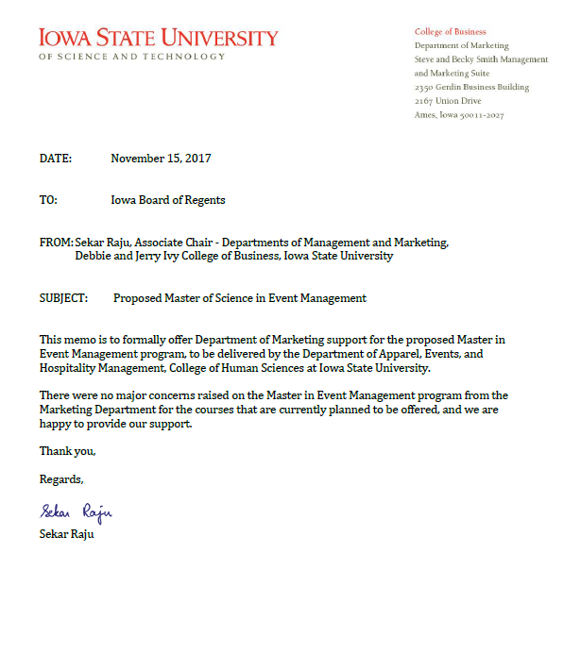

The University of Iowa Event Planning Certificate, The University of Iowa

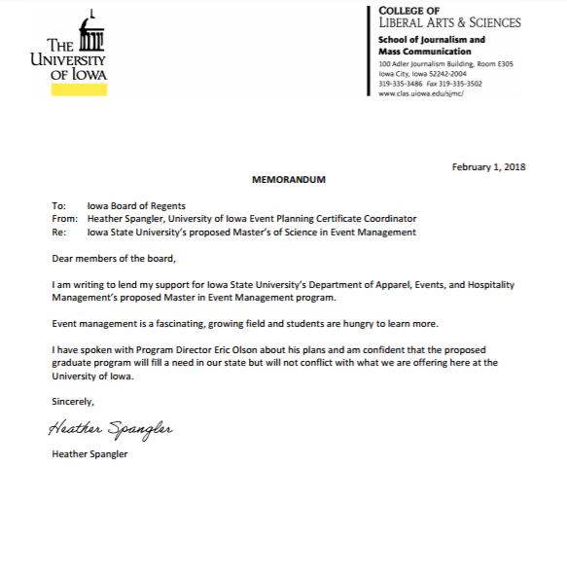

Meetings Professional International (Heartland Chapter)

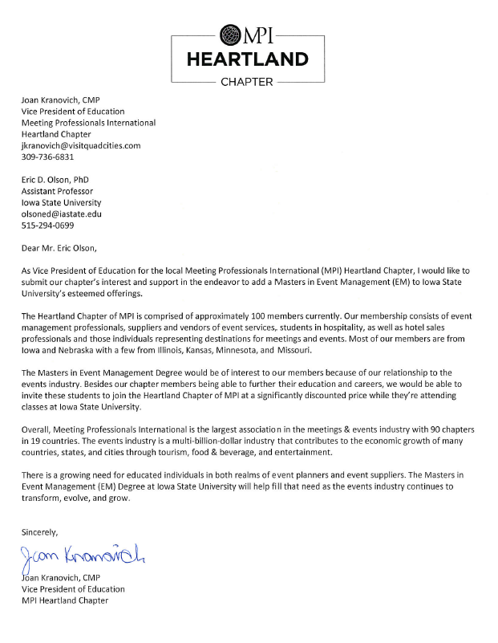

Professional Convention Management Association (Heartland Chapter)

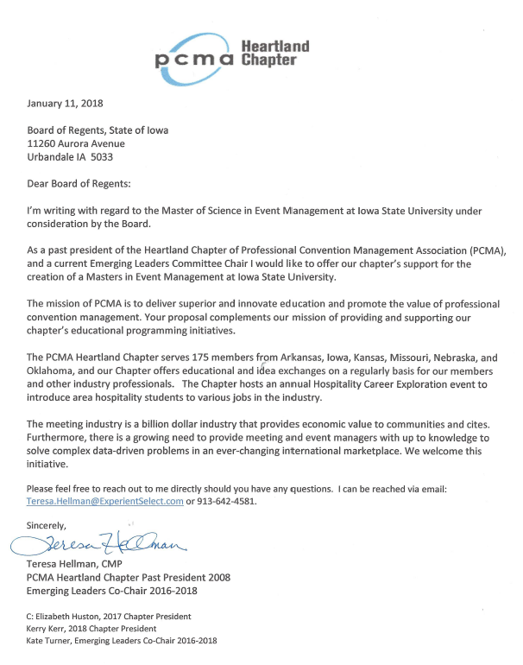

According to the Bureau of Labor Statistics (U.S. Department of Labor), the unemployment rate for those with a Masters degree is 2.4% (compared to those with a Bachelor’s degree at 2.7%). Furthermore, median weekly earnings for those with a Masters degree is 19.4%. Retrieved from https://www.bls.gov/emp/ep_chart_001.htm
Please see https://www.mpiweb.org/docs/default-source/Research-and-Reports/MBECS-Guide-APP-2-Standards.pdf
Pricewaterhouse Coopers, LLP. (2014). The economic significance of meetings to the U.S. Economy. Retrieved from http://www.eventscouncil.org/Files/2012%20ESS/CIC%20Meetings%20ESS%20Update%20EXECUTIVE%20SUMMARY-FINAL.pdf
Please see Fink, S. (2017, October 15). After the Las Vegas shooting, concertgoers became medics. The New York Times. Retrieved from https://www.nytimes.com/2017/10/15/us/las-vegas-shooting-civilian-first-aid.html
For example, San Diego State University will be launching a new graduate-level degree in Meeting and Event Management in 2019 (https://www.mpiweb.org/docs/default-source/2017-press-releases/mpi-sdsu-masters-degree-program-partnership-press-release-final.pdf).
Bureau of Labor Statistics (2017). Meeting, convention, and event planners occupational outlook handbook. U.S. Department of Labor. Retrieved from https://www.bls.gov/ooh/business-and-financial/meeting-convention-and-event-planners.htm
Getz, D., & Page, S. J. (2016). Event studies: Theory, research and policy for planned events. 3rd edition. Abingdon, Oxon: Routledge.
CHS Career Survey report.
Please see Getz, D., & Page, S. J. (2016). Event studies: Theory, research and policy for planned events. 3rd edition. Abingdon, Oxon: Routledge
Bureau of Labor Statistics (2017). Meeting, convention, and event planners occupational outlook handbook. U.S. Department of Labor. Retrieved from https://www.bls.gov/ooh/business-and-financial/meeting-convention-and-event-planners.htm
Miller, R., & Leskes, A. (2005). Levels of assessment: From the student to the institution. Association of American Colleges and Universities. Retrieved from https://www.aacu.org/sites/default/files/files/publications/LevelsOfAssessment.pdf

