2-2-18

FORM A

Board of Regents,

State of Iowa

REQUEST TO IMPLEMENT A NEW BACCALAUREATE, MASTERS, DOCTORAL, OR FIRST PROFESSIONAL DEGREE PROGRAM January 28, 2015

THE PURPOSE OF ACADEMIC PROGRAM PLANNING: Planning a new academic degree program provides an opportunity for a Regent university to demonstrate need and demand as well as the university’s ability to offer a quality program that is not unnecessarily duplicative of other similar programs offered by colleges and universities in Iowa.

Institution: Iowa State University (ISU)
CIP Discipline Title: Education
CIP Discipline Specialty Number (six digits): 13.0101
Level: D
Title of Proposed Program: Doctor of Education, major in Education
Degree Abbreviation: Ed.D.
Approx. date to establish degree (month/year): August 2019
Contact Person (name, telephone, and email): Dr. Marlene Strathe

Director, School of Education
(515) 294-2336
mstrathe@iastate.edu

College that will administer the new program: College of Human Sciences

Please provide the following information (use additional pages as needed). Do not use acronyms without defining them.

1. Describe the proposed new degree program, including the following:

- A brief description of the program. If this is currently being offered as a track, provide justification for a standalone program.

Since 1869, when students first began coursework at what was then Iowa Agricultural College, the preparation of educators has been one way in which the University has fulfilled its land-grant mission to serve the people of Iowa. As the field of education developed over the course of the 20th Century, educator preparation at Iowa State broadened from teacher education to the preparation of educational leaders. For this proposal, two developments are particularly noteworthy. First, in 1913, with the emergence of the modern school system and educational administration as a field of study, ISU began preparing school leaders, such as principals and superintendents. Second, in 1965, with the passage of the Merged Area Schools Act, which began the formation of the community college system in Iowa, ISU began to focus attention on the preparation of community college leaders.
In accordance with the land-grant mission of the University to serve the people of Iowa and our mirrored historical commitment to the field of education and the preparation of P-20 (pre-school through college) systems-level leaders in the State of Iowa, ISU’s School of Education is requesting permission to grant a Doctor of Education degree (Ed.D.) with a major in Education.
The School of Education currently offers a Doctor of Philosophy (Ph.D.) with a major in Education. Because the Ph.D. and the Ed.D. offer preparation for different professional expertise, it is the norm for schools of education to offer both degrees. This is the case with seven of ISU’s ten designated peer institutions (UC Davis, U of Illinois-Urbana-Champaign, Michigan State, North Carolina State, Ohio State, Penn State, and Texas A&M) and the case with the large majority of ISU’s peers in the American Association of Universities (AAU) that offer a Ph.D. in education, including top ranked public graduate schools of education (e.g., UCLA, UT-Austin, U of Virginia, and U of Washington) and top ranked private graduate schools of education (e.g., Columbia, Harvard, Johns Hopkins, and Vanderbilt). The appendix includes a table with the features of several established programs to provide a context for this proposal.
The Ph.D. prepares educational researchers who conduct methodologically rigorous scholarship that significantly contributes to knowledge in the field of education. By comparison, while preparing students to engage in educational research, an Ed.D. primarily prepares educational leaders (known in the field of Education as “scholarly practitioners”) who can apply scholarly research to problems of practice in local, state, and national settings. The Ph.D. is a research doctorate that prepares students for careers in educational research. The Ed.D. is a professional doctorate that prepares students for leadership in educational systems. Thus, while the Ph.D. prepares students to take positions as faculty in colleges and universities and as professional researchers in a variety of private and government settings, the Ed.D. prepares students to work as leaders in school districts, community colleges, in state departments of education, in Area Education Agencies, and a variety of other educational and youth development agencies.
The School of Education envisions an Ed.D. that produces transformational, equity-focused leaders for education systems across the P-20 continuum. The program will be cohort-based, three-years in length (including two summers; total of eight semesters), and culminate in a dissertation demonstrating the use of critical inquiry to address a complex problem of practice. The program will also offer a select number of professional tracks (e.g., Community College Leadership and P-12 Systems-Level Leadership). All students, regardless of track, will take a core curriculum that develops student understanding of the scope, substance, and inter-relationship of the P-20 schooling continuum. The cohort model aims to stimulate a shared learning experience among students, fostering the development of professional networks and encouraging dialogue among emerging leaders across the educational system. To best meet the needs of working professionals, the program will be delivered in hybrid formats that mix face-to-face learning with videostreaming and online delivery methods. If approved, the proposed program will replace two currently existing options within the SOE. The first is an alternative delivery format (all-day Thursday/Friday courses) PhD program with an emphasis on community colleges; the second is a Certificate of Advanced Study (30 credit graduate certificate) aligned with Iowa Superintendent endorsement requirements.

- A statement of academic objectives.

The Ed.D. is guided by six principles identified by the Carnegie Project on the Education Doctorate (CPED), a national consortium of over 80 colleges and schools of education in the United States, including three of ISU’s designated peer institutions (Michigan State, North Carolina State, and Texas A&M), four additional AAU public land-grant peers (U of Florida, U of Maryland, U of Missouri, and Rutgers) and the U of Northern Iowa. The six principles establish that the Ed.D.:
- Is framed around questions of equity, ethics, and social justice to bring about solutions to complex problems of practice.
- Prepares leaders who can construct and apply knowledge to make a positive difference in the lives of individuals, families, organizations, and communities.
- Provides opportunities for candidates to develop and demonstrate collaboration and communication skills to work with diverse communities and to build partnerships.
- Provides field-based opportunities to analyze problems of practice and use multiple frames to develop meaningful solutions.
- Is grounded in and develops a professional knowledge base that integrates both practical and research knowledge, that links theory with systemic and systematic inquiry.
- Emphasizes the generation, transformation, and use of professional knowledge and practice.
These principles underpin our academic objectives. Students who complete the Ed.D. will demonstrate an ability to:

- Identify and address issues of equity, ethics, and social justice central to bringing about solutions to complex problems of practice.
- Construct and apply knowledge to make a positive difference in the lives of individuals, families, organizations, and communities.
- Collaborate, communicate, and build partnerships with diverse communities.
- Analyze problems of practice and use multiple frames to develop meaningful solutions.
- Integrate both practical and research knowledge, that links theory with systemic and systematic inquiry.
- Use professional knowledge and practice in the generation of solutions and transformation of educational institutions.
In addition to these broad academic objectives, because the Ed.D. is designed to prepare scholarly practitioners for professional practice in specific types of educational systems (e.g., community colleges and P-12 school systems) the degree program also aligns with leadership competency standards established by national organizations, including the American Association of Community Colleges (AACC), American Council on Education (ACE), and the University Council for Educational Administration (UCEA) and with state certification standards for P-12 systems-level leaders. Students will thus gain advanced knowledge and skills in core areas, including:

• Administrative and Organizational Leadership
• Budget and Financing
• Cultural Diversity and Inclusion
• Public Policy Analysis
• Theories of Learning and Student Development.

A scope and sequence of the core curriculum is attached as an appendix.

- What the need for the program is and how the need for the program was determined.

Iowa State University has been preparing P-12 systems-level leaders, such as superintendents, since the emergence of the modern school system in the early 20th century, and preparing community college leaders since the formation of the community college system in Iowa began with the passage of the Merged Area Schools Act in 1965.
The School of Education currently prepares students for P-12 systems-level leadership in a graduate certificate program (Certificate of Advanced Study), and prepares community college leaders as an area of emphasis in the Ph.D. program with a major in Education. The community college program, which is the only one of its kind in the state, is widely recognized as a national leader. The program also assumes a leadership role in the preparation of community college leaders in Iowa through the initiation and administration of, since 1989, the Leadership Institute for a New Century (LINC), which has had a significant influence in preparing women and people of color for leadership in community colleges, and through the initiation and administration of, since 1995, the Community College Leadership Initiative Consortium (CLIC), which focuses on the development of mid-and-upper-level community college administrators. Both initiatives were led by School of Education Professor Emeritus Larry Ebbers, a leading figure in community college leadership in the state and nationally.
The School of Education is proud of the P-12 systems-level and community college leadership programs. Graduates of these programs and connected initiatives have assumed numerous leadership positions in the state. For example, several ISU alums currently serve as superintendents in Iowa and 11 of the 15 current presidents of community colleges in Iowa are former ISU students.
Yet, to better meet the needs of students and the institutions and communities they will eventually serve, we believe it is time to reexamine our programs. We undertook an extensive program review, including studying the scholarly literature on P-20 educational leadership to determine best practices in program design and leadership preparation. We found that there is general agreement in the field of education (and amongst our peer institutions) that a well-designed Ed.D. is the best way to prepare scholarly practitioners for leadership positions in P-20 educational systems. This is because the Ed.D., unlike the Ph.D., is specifically designed to prepare scholarly practitioners, and unlike stand-alone certificate programs, the Ed.D. offers the appropriate course of study and degree standing that such rigorous preparation demands. The creation of an Ed.D. would thus enable the School of Education to follow best program practices in the field and enable us to meet the needs of students and the institutions and communities they will serve.
Iowa State has been preparing students for P-12 systems-level leadership and community college leadership for decades. We view the creation of an Ed.D. as a more appropriate degree program for scholarly practitioners and continuation of the University’s historical commitment to the preparation of educational leaders. This noted, we want to make clear that there is a significant need in Iowa for the continued preparation of P-12 systems-level leaders and community college leaders. We also want to note the need to prepare all educational leaders, including P-12 and community college leaders, with a broad grounding in the P-20 continuum. Below we briefly discuss these specific needs.

P-12 Systems-Level Leadership

At the P-12 systems-level, the most recent data reported by the State of Iowa (2016-2017), indicates that there are 272 full-time superintendents in the state. Of these, 186 (or 68%) have 20 or more years of experience. Retirements are imminent. There is thus an understandable concern amongst state educational leaders about the ability to fill these positions with highly qualified candidates. In addition to preparing educational leaders for the position of superintendent, a systems-level program will prepare leaders for other positions, such as associate superintendents, various district-level central office positions, and as administrators in AEAs and the Iowa Department of Education. These positions are numerous across the state and consistently in need of high quality staffing.
Given the demand in the state, it should be clear that the State of Iowa continues to require multiple programs to meet the systems-level staffing needs across the state. Each Regents institution (ISU, UNI, and UI), as well as Drake University, will thus need to continue to produce high-quality leaders. Based on a close study of the Carnegie Project on the Education Doctorate and scholarly literature on P-12 leadership (e.g., Peterson, 2017; Perry, 2016; Planning and Changing, 2013), we believe that an Ed.D. will enable Iowa State to continue to best prepare the high-quality leaders the state deserves and demands.

Community College Leadership

At the community college level, there is a significant need to continue preparing community college leaders in the state and nationally. Iowa State is not only the one program in the state specifically designed to prepare community college leaders, but it is one of only a few doctoral programs in the nation focused on community college leadership (Strom, Sanchez, & Downey-Schilling, 2011). This shortage of doctorate programs for community college leaders is troublesome because many current leaders are nearing retirement, and there is not a strong pipeline of available leaders to fill the vacancies (Strom et al., 2011). As Christopher Duree, now President of Iowa Valley Community College, found in his 2007 dissertation completed at Iowa State, 91% of 451 national community college presidents surveyed in his study were aged 50 or older. Now, a decade later, the youngest of those participants are approaching retirement age.
The State of Iowa has long valued community colleges, which serve a distinct purpose in higher education. For instance, community colleges offer certifications and associate’s degrees that are not available at baccalaureate institutions. These credentials are of vital significance in the workforce. And significantly, there is a dramatic shortage of workers to fill positions that require these credentials both in Iowa and in the nation (Carnevale, Smith, Gulish, & Hanson, 2015; Central Iowa Works, 2017; Eathington & Swenson, 2015; Fehrenback, 2014; Iowa Workforce Development, 2015). Moreover, community colleges, because of their localized nature, can respond to these and other critical issues in ways that larger, four-year institutions are not able to do alone.
Community colleges thus remain vital to the health of the state and nation. As such, it is imperative that institutions, such as Iowa State, continue to prepare community college leaders, especially ones who can respond to a range of rapid economic, social, and cultural changes. This is one reason why scholars, such as ISU-associated scholars McNair, Duree, and Ebbers (2011), argue that we need programs particularly designed to prepare community college leaders, from mid-level administration to the community college president.

P-20 Leadership

In addition to a continued need to prepare P-12 systems-level leaders and community college leaders, the unique P-20 framing of the program addresses a need to prepare educational leaders to understand the complexity of the P-20 continuum. Nowhere is this complexity more evident than in state and federal educational policy, which is increasingly crafted through the lens of a P-20 system (e.g., Chamberlin & Plucker, 2008; Rippner, 2016, Rippner, 2017; Walsh, 2009). Leaders at all levels of the P-20 continuum must thus have the awareness, understanding, and necessary skills to navigate educational institutions in a P-20 educational landscape that is increasingly organizationally, financially, and politically interlocking and complex.

- The relationship of the proposed new program to the institutional mission and how the program fits into the institution’s and college’s strategic plan.

Land-grant institutions were founded with the purpose of preparing practically-oriented professionals to serve the needs of local and state communities. As Iowa’s land-grant university, Iowa State is committed to and guided by this applied mission.
The School of Education at Iowa State University is grounded in the larger mission of Iowa State. The School is “committed to engaging in rigorous and socially meaningful research, preparing leaders and practitioners across the P-20 continuum that support rich and equitable learning opportunities for all students, and supporting public education as a cornerstone of a healthy, vibrant, and just society. We strive to be a national leader in educational theory, policy, and practice, and to honor the land-grant tradition and the broader mission of the university to serve the people of Iowa.”
The School of Education views the preparation of P-20 educational leaders as a part of its institutional responsibility as the school of education at the state’s land-grant university. The creation of an Ed.D. to prepare scholarly practitioners for leadership in P-20 educational systems will best enable the SOE to meet this responsibility.

- The relationship of the new program to other existing programs at the institution; describe how the proposed program will enhance other programs at the university. Will the proposed program duplicate existing programs at the university?

As discussed in 1.c., existing programs in community college leadership (currently offered as an area of emphasis in the Ph.D. program) and P-12 systems-level certification (currently offered as a graduate certificate), will become tracks in the Ed.D. The new degree will provide a learning context specifically designed for the professional needs of students in these programs, including time to degree (three years for the Ed.D. in contrast to four to six for the Ph.D.) and delivery format (Ph.D. is predominantly on-campus; Ed.D. will be delivered using hybrid formats.

- The relationship of the proposed new program to existing programs at other colleges and universities in Iowa, including how the proposed program is different or has a different emphasis than the existing programs.

Doctor of Education (Ed.D.) degrees are currently offered at the University of Northern Iowa and Drake University. The University of Iowa does not currently offer an Ed.D. Available areas of emphasis at UNI include: Applied Health, Recreation, and Community Services; Curriculum and Instruction; and, Educational Leadership. Drake offers two areas of emphasis: Leadership (broadly defined across education, government, business, healthcare, and legal and human services) and Educational Administration with Superintendent Licensure.
The Ed.D. in the School of Education will be unique in its P-20 framing and program design. No other institution in Iowa takes an approach that explicitly and intentionally grounds educational leadership preparation in P-12 and post-secondary settings, such as community colleges, in an understanding of the social foundations of the P-20 continuum.
In terms of duplication of offerings, no other institution in the state offers an Ed.D. with a track in Community College Leadership. This will be a unique feature of the Ed.D. at Iowa State. Furthermore, as noted in 1.c., the state needs multiple P-12 systems-level preparation programs in order to meet state staffing needs. UNI, Drake, Iowa (which offers superintendent certification but not an Ed.D) and ISU must all remain active in systems-level preparation. An Ed.D. at ISU will give students one more option to choose from for such preparation.

- Special features or conditions that make the institution a desirable, unique, or appropriate place to initiate such a degree program.

Land-grant institutions were founded with the purpose of preparing practically-oriented professionals to serve the needs of local and state communities. As Iowa’s land-grant university, Iowa State is committed to and guided by this applied mission. The School of Education at Iowa State is thus uniquely suited for an Ed.D.
Additionally, no other institution in Iowa offers an Ed.D. with a focus in Community College Leadership. Iowa State is a particularly appropriate place to offer an Ed.D. with a focus in Community College Leadership because it has an established national reputation, core elements of a curriculum already in place, and tenured/tenure-track faculty with expertise in community colleges.

- Are the university’s personnel, facilities, and equipment adequate to establish and maintain a high quality program?

Current personnel, facilities, and equipment are in place to establish and maintain a high quality Ed.D. program. Because the Ed.D. will focus on the preparation of scholarly practitioners as opposed to the Ph.D. program, which focuses on the preparation of educational researchers, the new degree will better enable Iowa State to meet the needs of students and the institutions and communities they will serve as P-20 educational leaders. Furthermore, the Ed.D. hybrid delivery format will be designed for working professionals who are pursuing career goals related to community college leadership and P-12 systems-level leadership. We expect a large majority of students will find the proposed Ed.D. better suited to their needs. No additional resources will be required of the proposed program.

- How does student demand for the proposed program justify its development?

There is student demand in both community college leadership and P-12 systems-level leadership.
In 2007, Iowa State started a new graduate certification program leading to certification as a superintendent in Iowa (CAS: Certificate of Advanced Studies). Since 2007, ISU has had 7 cohorts, each running for two years. In total, 63 students have been enrolled in these cohorts with 8 enrolled in the current cohort, which is scheduled to graduate in Summer 2018. Alums of the program have assumed positions as superintendents, central office administrators, administrators in AEAs and other positions. In addition to historical interest, there is current interest, most recently evidenced by numerous inquiries at the 2017 School Administrators of Iowa conference. Furthermore, based on student feedback, the job market, and the direction of the field, we believe that many students will be more interested in ISUs program if it is degree granting (especially doctoral degree-granting) as opposed to just a certificate program. We believe that an Ed.D. track in P-12 systems-level leadership will easily be able to sustain 10-12 new students every two years.
Recent enrollments indicate student interest and enrollment for this program. Table 1 provides recent data by fiscal year (including fall, spring, and summer sessions) showing the number of students admitted the number of those who enrolled, and the number who completed the program.

Table 1. Data for past five years in existing programs
Year | Admitted | Began program | Total in program† | Graduated/  Completed
Community College
2012-13* | 2 | 1 | 79 | 21
2013-14 | 20 | 15 | 88 | 16
2014-15 | 17 | 13 | 70 | 12
2015-16 | 6 | 4 | 65 | 9
2016-17 | 8 | 6 | 47 | 20
CAS: Superintendent
2012-13* | 0 | 0 | 18 | 8
2013-14 | 8 | 6 | 6 | 7
2014-15 | 0 | 0 | 5 | 1
2015-16 | 9 | 9 | 14 | 5
2016-17 | 0 | 0 | 8 | 0
† Total in program includes students in SOE records; not all may have been registered each semester. Records through 13-14 included students who were inactive (had not enrolled for the past two years). * No data available for F12.

2. Describe the state and/or national workforce need and/or demand for graduates of the proposed program currently and in the foreseeable future (provide documentation about the current sources of data used to estimate need and demand).

See section 1.c.

3. List all other public and private institutions of higher education in Iowa currently operating programs similar to the proposed new degree program. (For comparison purposes, use a broad definitional framework, e.g., such identification should not be limited to programs with the same title, the same degree designation, having the same curriculum emphasis, or purporting to meet exactly the same needs as the proposed program.)

University of Northern Iowa
Drake University

If the same or similar program exists at another public or private institution of higher education in Iowa, respond to the following questions:

- Could the other institution reasonably accommodate the need for the new program through expansion? Describe collaboration efforts with other institutions.

Given the impending demand for school leaders, we believe that multiple programs for P-12 systems-level leaders are needed to meet statewide staffing needs. The other programs do not have expertise in community college leadership, so expanding their programs would require adding faculty with the expertise that is already in place at ISU.

- With what representatives of these programs has there been consultation in developing the program proposal? Provide a summary of the response of each institution consulted.

We have consulted with representatives of the University of Iowa, the University of Northern Iowa, and Drake University regarding this proposal.
On October 5, Dr. Sue Mattison, Provost at Drake University was contacted to request an opportunity to meet with the School of Education faculty at Drake to discuss the Ed.D. proposal. She later indicated that Drake viewed the program as in competition with Drake’s program and declined further communication between the two institutions.
On October 25, we learned that the University of Iowa was also preparing an Ed.D proposal. We have since been in conversation with Dean Daniel Clay about our respective programs. His letter of strong support is attached.
In November, Dean Laura Jolly met with Dean Gaëtane Jean-Marie of the College of Education at the University of Northern Iowa to discuss our programs. We have attached Dean Jean-Marie’s letter.

- Has the possibility of an inter-institutional program or other cooperative effort been explored? What are the results of this study? (Consider not only the possibility of a formally established inter-institutional program, but also how special resources at other institutions might be used on a cooperative basis in implementing the proposed program solely at the requesting institution.)

Given the concentration of faculty expertise in community college leadership at ISU, and the absence of such expertise at other institutions, we have not explored cooperative efforts related to the community college track. Data on P-12 systems leaders in Iowa support the need for continuing the existing programs at multiple institutions to meet current and expected demands for P-12 leaders.

- Do other colleges in Iowa offer programs similar to the proposed program at comparable quality and cost?

As noted earlier, there are no other similar programs with a P-20 focus at other institutions. See also 1.c. and 3.a.

- Are letters of support included with the program proposal?

Letters are appended from the University of Iowa and the University of Northern Iowa.

4. Estimate the number of major and non-major students that are projected to be enrolled in the program during the first seven years of the program.

- Undergraduate

Not applicable, this is a graduate program.
- Graduate

We have examined past admissions to the alternative delivery format in the community college leadership program, which have ranged from 6 to 20. We have also examined past enrollment in the certificate program for P-12 systems-level leadership, which have similarly ranged in numbers. We expect to admit 20-24 students per Ed.D. cohort, with admissions occurring every other year and students completing the program in three years. Annual enrollment projections are presented in Table 2.

Table 2. Projected enrollments in Ed.D. program
Graduate | Yr 1 | Yr 2 | Yr 3 | Yr 4 | Yr 5 | Yr 6 | Yr 7
Majors | 20-24 | 20-24 | 40-48 | 20-24 | 40-48 | 20-24 | 40-48
Non-Majors | 0 | 0 | 0 | 0 | 0 | 0 | 0

- What are the anticipated sources of these students?

We expect that the majority of the students who have chosen Iowa State’s alternative delivery format PhD with a focus in community college leadership and the graduate certification program in P-12 systems-level leadership in the past are likely to be attracted to this program. Though the track in P-12 systems-level leadership will not be dependent on out-of-state students (see existing needs in Iowa noted in 1.c.), there is reason to believe that an Ed.D. will increase the attractiveness of the program to students in neighboring states that are looking for an Ed.D. in systems-level leadership. The community college leadership program already attracts students from out of state but we believe the improvements to the program will enhance the desirability of the Ed.D.

5. If there are plans to offer the program away from the campus, briefly describe these plans, including potential sites and possible methods of delivery instruction. Will off-campus delivery require additional HLC accreditation?

There are no plans to offer the program away from campus. We currently anticipate continuing to use full-day on-campus class sessions in combination with videostreaming, virtual assignments, and online class activities between the on-campus sessions.

6. Has the proposed program been reviewed and approved by the appropriate campus committees and authorities?

See attached FSCC Voting Record document.

7. List date the program proposal was submitted to the Iowa Coordinating Council for Post High School Education (ICCPHSE) and results of listserv review.

Pending internal ISU approval.

8. Will the proposed program apply for programmatic accreditation? When?

N/A

9. Will articulation agreements be developed for the proposed program? With whom?

N/A

10. Will there be opportunities for student internships?

No.

11. Describe the faculty, facilities, and equipment that will be required for the proposed program.

Ten faculty currently participate in the PhD emphasis in Community College Leadership and the Certificate of Advanced Study graduate certificate program leading to recommendation for a superintendent endorsement. The proposed new program will not require any new faculty lines; faculty currently teaching in the existing programs will reallocate their effort to the Ed.D. The proposed program will use existing facilitates (Lagomarcino Hall) and equipment (technology in classrooms). No new facilities or equipment will be required.

12. From where will the financial resources for the proposed program come (list all that apply, e.g., department reallocation, college reallocation, grants, new to the university)?

Financial resources for the program include portions of the salaries of the ten faculty who will be participating in the Ed.D. program. All of these faculty currently have a portion of their time allocated to supporting the Community College emphasis in the PhD program or the Certificate of Advanced Study superintendent program. Given the standard assignments of School of Education faculty (40% teaching, 40% research, 10% institutional service, 10% professional service), we used 25% of each faculty member’s position for our estimate. This includes half of their teaching responsibilities (20%), as all are also involved in master’s programs, and half of their institutional service (5%) to account for programmatic service (e.g., recruiting, committee work). Because the Ed.D. will replace the other programs, no additional resources are needed.

SOURCES | TOTAL AMOUNT
Existing college salary allocation | $212,750 (Year 1)

13. Estimate the total costs/total new costs (incremental increases in expenditures) that will be necessary for the next seven years as a result of the new program. Be as specific as possible.

 | TOTAL COSTS | TOTAL NEW COSTS
Year 1 | $212,750 | 0
Year 2 | $219,132 | 0
Year 3 | $225,706 | 0
Year 4 | $232,477 | 0
Year 5 | $239,451 | 0
Year 6 | $246,635 | 0
Year 7 | $254,034 | 0

Total costs include 25% of the SOE contribution to 9-month base salaries of 10 existing faculty members who will contribute to the proposed new degree. Total costs also include fringe benefits at the current rate of 27.5%. Year-to-year increases assume a 3% raise for each faculty member and no increase in benefits rates. Total costs are existing costs that will be incurred with, or without, the adoption of this proposal.
Because the program uses existing faculty lines and no new faculty, facilities or equipment will be needed, total new costs of the proposed degree program equal $0 per year.

14. Describe the marketing plan developed to communicate the new program and recruit students.

The School of Education will market the Ed.D. by leveraging the strong relationships we have fostered over many years with a range of educational communities. The networks Iowa State has developed to build its national reputation in community college leadership will be a strong asset in marketing the new program. Similarly, Iowa State has long prepared P-12 administrators and has a network of school leaders that it will utilize to market the new program. We will also continue to participate in resource fairs and marketing opportunities at P-12, community college, higher education, and related group association meetings, conferences, and events. (A representative list is provided below.) Additionally, we will capitalize on our Internet presence and social media outlets to engage with prospective students, as we are already doing with other specializations in the SOE, such as student affairs in higher education and P-12 principal licensure. Recognizing that our target audience is students who are current working professionals looking for career advancement, we will also continue to work closely with our community college and P-12 school partners in identifying potential community college and P-12 systems-level leaders. Our broad network of ISU alumni will play a pivotal role in word-of-mouth advertising. Marketing this new degree program will not to be an added burden for faculty and staff within the SOE.

Community Colleges

- Consortium for Computing Sciences in Colleges (CCSC)
- American Association of Community Colleges (AACC)
- Iowa Association of Community College Trustees (IACCT)
- Cooperating Libraries in Consortium (CLIC) / LINC,
- Association for the Study of Higher Education (ASHE)
- American Education Research Association (AERA)
- American College Personnel Association (ACPA)
- Student Affairs Professionals in Higher Education (NASPA)
- National Conference on Race and Ethnicity (NCORE)
- American Association of Hispanics in Higher Education (AAHHE)
- National Association of Developmental Education (NADE)
- College Reading and Learning Association (CRLA)
- Iowa Development Education Association (IDEA)
- Midwest Regional Association for Developmental Education (MRADE)
- Iowa Latino/a Conference
- Iowa Network for Women in Higher Education

P-12 Educational Leadership

- American Association of School Administrators (AASA)
- American Educational Research Association (AERA)
- Iowa Area Education Agencies (AEAs)
- Iowa Association for Supervision and Curriculum Development (Iowa ASCD)
- Iowa State Education Association (ISEA)
- School Administrators of Iowa (SAI)
- University Council of Educational Administrators (UCEA)
- Urban Education Network of Iowa

15. Describe the program evaluation plan to determine if the program is meeting the intended objectives, if the expected student enrollment has occurred, funding for the program, and any other components that affect the effective operation of the program.

Plans to assess the general academic objectives, articulated in section 1.b. of this document, will be developed by faculty members assigned to the Ed.D. program. Specific learning objectives for students in either programmatic track of the Ed.D. degree will be determined by faculty members within the specific areas. These objectives will be informed by standards of the appropriate professional organizations. Specifically, community college leadership objectives will be informed by the American Association of Community Colleges and the P-12 systems level leadership objectives by the University Council for Educational Administration. Both organizations provide specific guidance for preparation of senior level leaders.
Assessment of program objectives (e.g., application numbers, enrollment, graduation rate, time to graduation) will be the guided by the Director of Graduate Education (DOGE) and Division Leads for the two graduate divisions in the School of Education. Data necessary to assess achievement of these objectives are collected for existing programs through the School of Education Graduate Records Analyst, with similar program objectives assessed for existing programs. We anticipate incorporating assessment of the new Ed.D. program objectives into this existing process.

16. Include any additional information that justifies the development of this program.
N/A

References

Carnegie Project on the Education Doctorate (2017). http://www.cpedinitiative.org
Carnevale, A. P., Smith, N., Gulish, A., & Hanson, A. R. (2015). Iowa: Education and
workforce trends through 2025. Retrieved from:
https://cew.georgetown.edu/wp
content/uploads/Iowa_Wrkfrce2025.pdf.
Central Iowa Works (2017). Career pathways. Retrieved from: http://centraliowaworks.org/career-pathways.
Chamberlin, M. & Plucker, J. (2008). P-16 education: Where are we going? Where have we been? Phi Delta Kappan, 89, 472-479.
Duree, C. A. (2007) The challenges of the community college presidency in the new millennium: pathways, preparation, competencies, and leadership programs needed to survive. (Doctoral dissertation). Retrieved from Iowa State University Digital Repository. (Paper 15612).
Eathington, L., & Swenson, D. (2015, March). Exploring the skills gap in Iowa. Paper presented at the 54th Southern Regional Science Association Annual Meeting, Mobile, AL.
Fehrenbach, P. (2014). Workforce: The hole in the middle. Industryweek.com, (December 2014), 21-22.
Friedel, J. N. (2010). University-based community college leadership programs: Where future community college leaders are prepared. New Directions for Community Colleges, 149, 51-58.
Hirt, J. B. (2006). Where you work matters: Student affairs administration at different types of institutions. Lanham, MD: University Press of America.
Iowa Workforce Development (2015). Middle skill jobs in Iowa. Retrieved from: http://iwin.iwd.state.ia.us.
McNair, D. E., Duree, C. A., & Ebbers, L. (2011). If I knew then what I know now: Using the leadership competencies developed by the American Association of Community Colleges to prepare community college presidents. Community College Review, 39(1), 3-25.
Peterson, D. S. (2017). Preparing scholarly practitioners: Redesigning the EdD to reflect CPED principles, Impacting Education: Journal on Transformational Practice, 2(1), 33-40.
Perry, J. A. (Ed.) (2016). The EdD and the scholarly practitioner: The CPED path. Charlotte, NC: Information Age Publishing.
Planning and Changing: An Educational Leadership and Policy Journal (2013). Special Issue: Carnegie Project on the Education Doctorate, The education doctorate—a degree for our times, Planning and Changing: An Educational Leadership and Policy Journal, 44(3/4), 113-326.
Rippner, J. A. (2016). The American Education Policy Landscape. New York: Routledge.
Rippner, J. A. (2017). State P-20 Council and Collaboration Between K-12 and Higher Education. Education Policy, 31(1), 3-38.
Shulman, L. S., Golde, C. M., Bueschel, A. C., & Garabedian, K. J. (2006). Reclaiming education’s doctorates: A critique and a proposal. Educational Researcher, 35(3), 25-32.
Strom, S. L., Sanchez, A. A., & Downey-Schilling, J. (2011). Inside-outside: Finding future community college leaders. The Community College Enterprise, 17(1), 9-21.
Walsh E. J. (2009). P-16 policy alignment in the states: Findings from a 50-state survey.
In The National Center for Public Policy and Higher Education (Ed.), States,
schools, and colleges: Policies to improve student readiness for college and strengthen coordination between schools and colleges (pp. 23-34). Washington, DC: The National Center for Public Policy and Higher Education.
Weissner, C. A., & Sullivan, L. G. (2007). New learning: Constructing knowledge in leadership training programs. Community College Review, 35(2), 88-112.

Appendix

Proposed Curriculum Outline 20

Letter from University of Iowa 21

Letter from University of Northern Iowa 22

Table of Existing Ed.D. Programs 23

Proposed Curriculum for P-20 Ed.D.
Note: Field experiences appropriate to each track will be built into track courses.

Fall One (8 credits) Credits Delivery
EL PS 610AX Doctoral Seminar I: Practitioner-Scholar Leadership 1 On-line
EL PS 612X Social Foundations of P-20 Schooling 3 Hybrid
Track Course (Community Colleges or K-12 Leadership) 3 Hybrid

Spring One (8 credits)
EL PS 610B Doctoral Seminar II: Aligning P-20 Educational 1 On-line
Contexts
EL PS 614X Organizational Theory 3 Hybrid
Track Course (Community Colleges or K-12 Leadership) 3 Hybrid

Summer One (8 credits)
EL PS 610CX Doctoral Seminar III: Evidence-Based 1 On-line
Decision-Making
EL PS 618X Contemporary Issues of Equity and Diversity 3 Hybrid
Track Course (Community Colleges or K-12 Leadership) 3 Hybrid

Fall Two (8 credits)
EL PS 610DX Doctoral Seminar IV: Identifying Research Topic 1 On-line
ResEv 552 Basic Educational Statistics 3 Hybrid
Track Course (Community Colleges or K-12 Leadership) 3 Hybrid

Spring Two (8 credits)
EL PS 610EX Doctoral Seminar V: Developing Research Design 1 On-line
C I 515 Action Research 3 Hybrid
Track Course (Community Colleges or K-12 Leadership) 3 Hybrid

Summer Two (8 Credits)
EL PS 610FX Doctoral Seminar VI: Writing Research Proposal 1 On-line
ResEv 597 Program Evaluation and Assessment 3 Hybrid
Track Course (Community Colleges or K-12 Leadership) 3 Hybrid

Fall Three (6 credits)
EL PS 616 Doctoral Capstone (Exam) 6 N/A

Spring Three (6 credits)
EL PS 699 Dissertation Credits 6 N/A

Total Credits 54

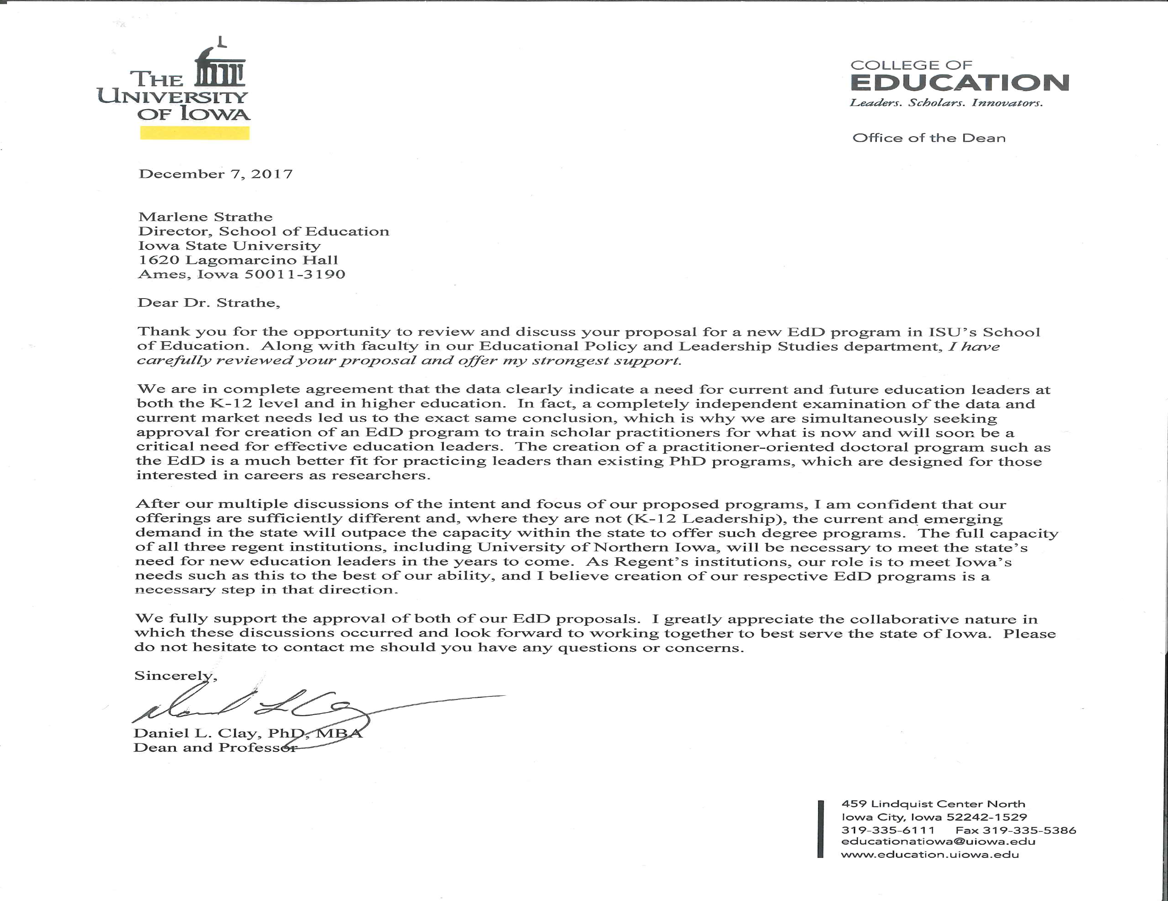
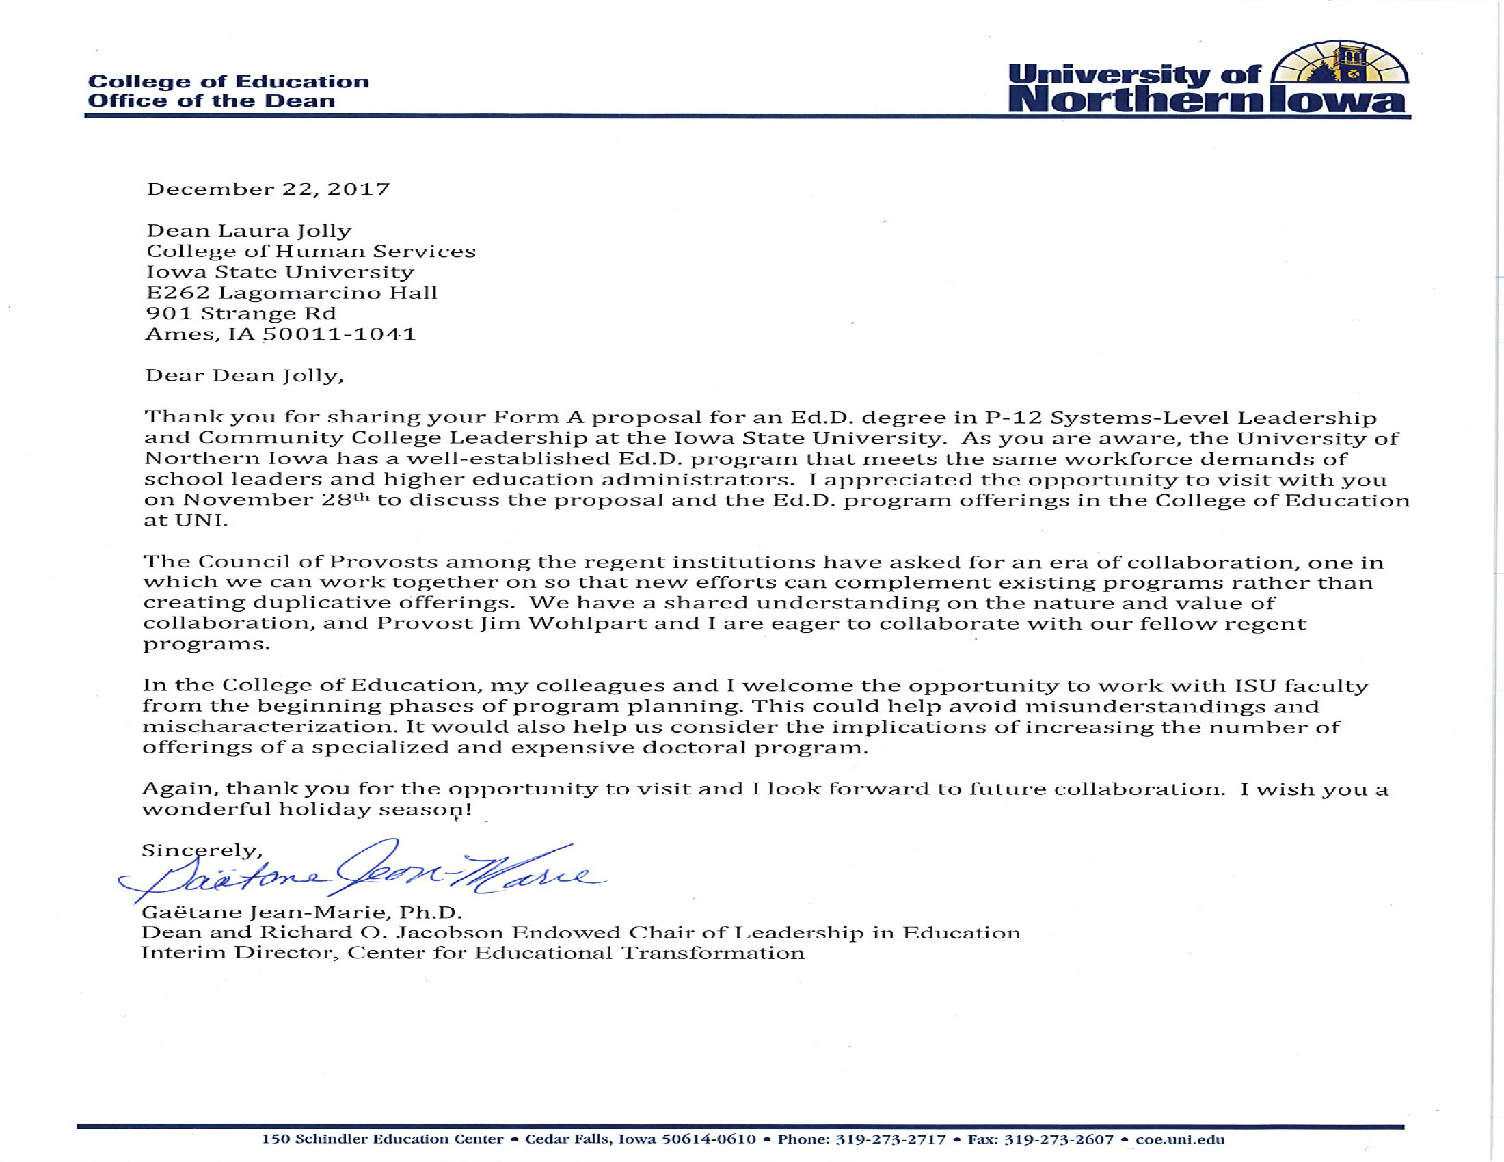
Descriptions of Other Education Doctorate Programs

Institution | Emphasis area(s) | Cohort-based? | Duration in years | # of required credits | # of transfer credits allowed | Target students | Delivery format | Dissertation/  Prelim Exam Format
Existing Iowa Ed.D. Programs
University of Northern Iowa | 3 Intensive Study Areas for Ed.D. in Education  - Allied Health, Recreation, and Community Services  - Curriculum & Instruction  - Ed Leadership/ Special Ed Director | Not described on website | Not listed on website, does not appear to be cohort-based | 60 credits | 15 credits | Working professionals who hold a master’s degree | Not described on website | Comprehensive Exams (no credits)  Dissertation (6 credits)
Drake University | - Ed.D. in Leadership  - Ed.D. in Ed Administration with Superintendent Licensure | Not described on website | 3 years | 42 credits for Ed.D. in Leadership  54 credits for Ed.D. in Ed Ad. w/ SL | None | Working professionals who hold a master’s degree | On campus On weekends | Not described on website
Ed.D. Programs in Peer-11 Institutions
UC-Davis*  Quarter system | - Ed.D. in Ed Leadership (schools, community colleges, state and local education agencies) | Yes | 3 years | 96 units (quarter system) | Not described on website | Working professionals who hold a master’s degree | Friday classes (every 3rd) | No description of prelims/comps  Dissertation seminars (12 credits)  Dissertation (12 credits)
Illinois-Urbana Champagne | - Ed.D in Ed. Administration & Leadership Preparation  - Ed.D in Higher Education | No | 3 years (including summers) | 64 credits | None | Working Professionals | - On-line  - Residential (weekly)  - Friday-Sat (2x/month) | Qualifying Examination at end of coursework  Dissertation (16 credits)
Michigan State | - Ed.D in K-12 Administration | Not described on website | 3 years (including summers) | 48 credits | None | Working Professionals | Saturdays, 9a-1p | Comprehensive Examination after second year  Capstone (16 credits) seminars/projects

North Carolina State | - Ed.D in Adult and Community College Education  - Ed.D in Educational Leadership | Yes | 3.5 years | 54 credits | None | Working Professionals | Twice a month on Fridays (4p-9p) & Saturdays (8a -5p) | Internship  No description of prelims/comps  Dissertation (9-12 credits)
Penn State | - D.Ed in Educational Leadership  - D.Ed in Higher Education | No | Unclear | 90 credits | 30 credits | Full-time students | On-campus (University Park or Harrisburg) | Comprehensive examination at end of coursework  Dissertation (15 credits)
Ohio State | - Ed.D. in Educational Studies (Educational Administration)  - Ed.D. in Educational Studies (Higher Ed and Student Affairs) | Not described on website | Not described on website | 51 credits in Ed Ad  63 credits in Higher Ed | 9 credits from master’s | Working professionals who hold a master’s degree | Not described on website | No description of prelims/comps  Dissertation (6 credits)
Texas A&M | - Ed.D. in Education (Educational Administration) | Not described on website | 3.5, including a semester of professional internship | 69 | Not described on website | Not described on website | Saturday classes; traditional and online | Record of Study as culminating research project
Ed.D. Programs in Selected AAU Institutions
UCLA (quarter system) | - Ed.D. in Educational Leadership (K-16) | Yes | 3 years | 94 credits (quarter system) | None | Working professionals | Evening and weekend classes | Written qualifying exam  Dissertation (18 credits)
UT-Austin | - Ed.D. in Higher Ed Leadership  - Ed.D. in Public School Executive Leadership | No | At least 3 years (likely 4 or 5) | 63 credits in Higher Ed  69 credits in PSEL | 6 credits that were not previously used towards a degree | Not described | Not described | Written qualifying exam  Dissertation (6 credits, minimum)
Virginia | - Ed.D. in Administration & Supervision  - Ed.D. in Curriculum & Instruction (also available with specialization in Reading Education)  - Ed.D. in Higher Education | Yes | 2 years of coursework plus dissertation | 72 credits in A&S  78 credits in C&I  69 credits in Higher Ed | 18 credits from master’s in A&S  24 credits from master’s in C&I and Higher Ed | Working professionals | Blended instruction | Written comprehensive exam  Capstone Dissertation (12 credits)

