**Academic Program Approval Voting Record**

This document is to be appended as the last page of the proposal for any new or revised academic program to record the successive votes of approval as the proposal moves through its required review and approval steps. Consult Faculty Handbook Section 10.8 or the Faculty Senate Curriculum Committee website for information regarding Committee review and voting requirements for each action.

Curricular Action: (check appropriate boxes below)

1. □ New Program □ Name Change **X** Discontinuation □ Concurrent Degree for:

2. □ Undergraduate Major □ Graduate Major □ Undergraduate Minor □ Graduate Minor

□ Undergraduate Certificate □ Graduate Certificate □ Other: ___________________

3. Name of Proposed Change: __MS Transportation (interdisciplinary)___________

4. Name of Contact Person: e-mail address: ________________

5. Primary College: Engineering Secondary College:

6. Involved Department(s): CCEE

**Voting record for this curricular action:**

|  |  |  |  |  |
| --- | --- | --- | --- | --- |
|  | Votes | | |  |
| Voting Body | For | Against | Abstain | Date of Vote |
| **CCEE Faculty Vote** | **23** | **1** |  | **March 11, 2021** |
|  |  |  |  |  |
| **Dept. or Program Committee** | **6** | **0** | **0** | **September 5, 2023** |
|  |  |  |  |  |
|  |  |  |  |  |
| College Curriculum Committee |  |  |  |  |
|  |  |  |  |  |
| **ECCC** | **7** | **0** | **1** | **9/20/23** |
|  |  |  |  |  |
| College Approval Vote |  |  |  |  |
|  |  |  |  |  |
|  |  |  |  |  |
|  |  |  |  |  |
| Graduate Council |  |  |  |  |
| Faculty Senate Curriculum Committee |  |  |  |  |
| Faculty Senate Academic Affairs Council |  |  |  |  |
| Faculty Senate |  |  |  |  |

[FSCC – November 2013]

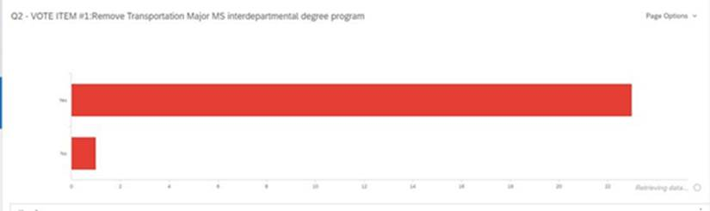CCEE Voting Record March 2021