DRAFT

Board of Regents, State of Iowa

REQUEST TO IMPLEMENT A NEW MASTERS DEGREE PROGRAM:
MASTER OF HUMAN COMPUTER INTERACTION

Institution: Iowa State University

Departments involved: Interdepartmental
CIP Discipline Specialty Title:
CIP Discipline Specialty Number (six digits):
Level: B M D FP
Title of Proposed Program: Master of Human Computer Interaction
Degree Abbreviation (e.g., Minor, B.S., B.A., M.A.): M.HCI
Approximate date to establish degree: Month: August Year: 2016
Contact person(s): James Oliver, HCI DOGE, 294-2649, oliver@iastate.edu
Nir Keren, Chair of MHCI subcommittee, 294-2580, nir@iastate.edu

Please provide the following information (use additional pages as needed).

- Describe the proposed new degree program, including the following:
  - A brief description of the program and a statement of objectives including the student learning outcomes and how the learning outcomes will be assessed.

Human-computer interaction is a discipline concerned with the design, evaluation and implementation of interactive computing systems for human use and with the study of major phenomena surrounding them. Because human-computer interaction studies a human and a machine in communication, it draws from supporting knowledge on both the machine and the human side. On the machine side, techniques in computer graphics, operating systems, programming languages, and development environments are relevant. On the human side, communication theory, graphic and industrial design disciplines, linguistics, social sciences, cognitive psychology, and human performance are relevant. And, of course, engineering and design methods are relevant.

– Association for Computing Machinery, Special Interest Group Computer-Human Interaction

The Iowa Board of Regents approved ISU’s interdepartmental graduate program in Human Computer Interaction (HCI) in 2003. With more than 200 students currently enrolled it is now the largest interdepartmental major at the university with faculty participation from all of ISU’s seven colleges. The program currently offers PhD, MS and Professional Certificate degrees.

The proposed Master of Human Computer Interaction degree will prepare professionals for successful careers at the interface between design, development, evaluation and management of technologies that enhance the productivity and creativity of people. This program will complement ISU’s existing research-focused MS in HCI degree; serving as a terminal degree for practicing professionals. The program will give the students a deep knowledge of interaction technology, behavioral and social science and human-centered design to develop useful and useable technology.

Learning outcomes are:

Students will design, evaluate and implement interactive computing systems for human use.

Students will analyze the major phenomena surrounding the interaction of people and technology.

Students will employ common effective strategies for improving systems for people.

Students will employ the necessary processes and tools to effectively manage both simple and complex projects.

Students will incorporate user experience into design.

Students will implement strategies for integrated interactions.

In their coursework and subsequent professional practice, students will account for ethical issues, moral dilemmas, and stakeholder responsibilities embraced by today's corporate decision makers.

Learning outcomes would be assessed by:
A variety of assessment strategies will be utilized to determine student learning outcomes, as defined by the Higher Learning Commission, the accreditation body for degree-granting post-secondary educational institutions in the North Central region. Assessment strategies will largely focus on engaging students in authentic activities relevant to what they are learning, including design, evaluation, and implementation projects, and using systematic processes such as carefully designed rubrics to evaluate the processes they employ and the products they produce.

  - The relationship of the proposed new program to the institutional mission and how the program fits into the institution’s, college’s, and department/program’s strategic plan.
By leveraging the breadth and depth of ISU disciplinary excellence, the graduate program in HCI has become an outstanding example of ISU’s commitment to fostering interdisciplinary research and education. The proposed degree will allow the HCI program to extend its impact to practicing professionals, which will bolster ISU’s land-grant mission.
  - The relationship of the proposed new program to other existing programs at the institution; describe how the proposed program will enhance other programs at the university.
In 2008, in response to increasing demand from industry, the leaders of the HCI graduate program modified the requirements of its MS program to accommodate online students. The primary innovation was the development of an online-only “Capstone Design” course that enables students to complete a summative three-credit research project that meets the MS requirement for a creative component. The response to this online MS has been outstanding, as shown in Figure 1, below.
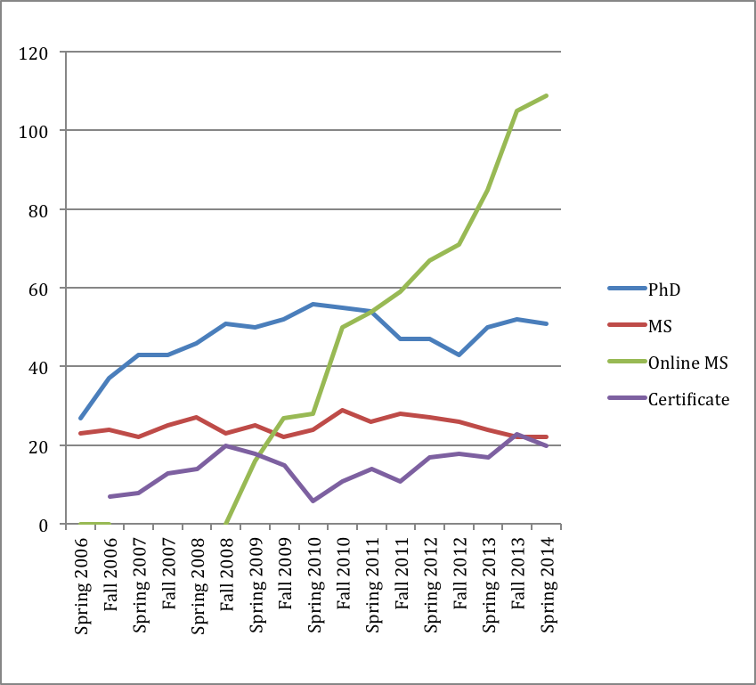
Figure 1: HCI Enrollment by degree

Figure 2, shows overall HCI program graduates per term, by degree, since the online MS was initiated. This graph clearly indicates that the online MS students are succeeding at completing the program, albeit over a slightly longer period of time relative to residential MS students.
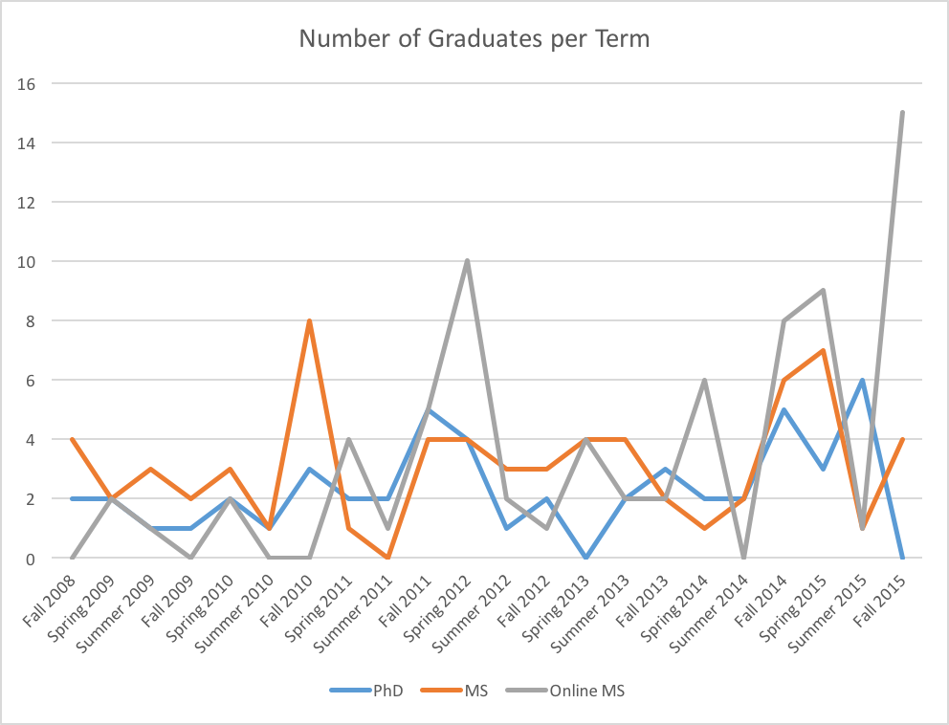
Unfortunately, the growth of the online MS degree has strained the ability of the program to sustain the Capstone Design course in its current form. In addition, many of the online students are not interested in research careers, so the MS experience is a relatively poor fit. Most online HCI MS students would prefer a course-work only, professionally oriented masters degree.
Thus, the proposed M.HCI degree will provide students with a unique combination of knowledge and skill not presently offered at ISU. By providing a coursework-only curriculum, the proposed program will broaden the spectrum of the programs offered by the HCI Graduate Program at ISU, which, until now, has focused on offering advanced degrees with a research focus.

  - The relationship of the proposed new program to existing programs at other colleges and universities in Iowa, including how the proposed program is different or has a different emphasis than the existing programs.
The proposed MHCI program will be the first program in Iowa, with its goal to offer a coursework-only HCI program specifically tailored to meet the diverse needs of professionals working in the industry. The proposed program differs from the existing programs at Iowa State, and other programs nationwide, in that it seeks to expose HCI practitioners to a well-rounded curriculum, will prepare them for the emerging challenges in HCI-related professions, and enable them to meet the expectations of this rapidly developing field.

  - Special features or conditions that make the institution a desirable, unique, or appropriate place to initiate such a degree program.
The HCI program at Iowa State is a well-developed graduate program that is recognized nationally and internationally. Growth of the M.HCI degree will benefit from its association with the Virtual Reality Applications Center, a highly successful research center that is seeking to increase its outreach for societal and industrial needs.
  - Does the proposing institution have personnel, facilities, and equipment adequate to establish and maintain a high quality program?
The proposed program will be delivered completely online. As a result of ISU’s commitment to providing quality online courses and improving online learning experience for students, the HCI Graduate Program has access to classrooms equipped with the latest instructional technologies to support, facilitate and enhance blended and hybrid courses, instructional technology support specialists who provide instructional design and support services, and technical assistance staff who support and maintain the infrastructure for the courses delivered online. Also, the HCI Graduate Program works in cooperation with the Engineering/LAS Online Learning office that has extensive experience in designing, supporting and improving online and blended courses. In addition, the courses that will constitute the curriculum for the proposed program have been offered at ISU for many years and the HCI faculty have substantial experience in designing and offering online and hybrid courses. Thus, the HCI Graduate Program, with its faculty experienced in online teaching and its state-of-the-art facilities, has adequate resources and technological infrastructure to accommodate the proposed program.

  - How does student demand for the proposed program justify its development?
As described in Section c, above, the motivation for the proposed M.HCI degree is the increasing demand for a coursework-only Masters program by professionals working in the industry who are interested in pursuing an advanced degree in HCI with a focus on practice, rather than research. Many HCI practitioners (and those that aspire to become one) work on HCI-related projects and wish to be equipped with HCI-related skills necessary to meet the expectations of their jobs. At the same time, they are reluctant to engage in the extensive research that a typical Masters degree requires. The proposed M.HCI program will address the need for a coursework-only program with an emphasis on practice. Although we will continue to offer the research-focused online MS in HCI degree, we anticipate that many of the students currently enrolled in it will transfer to the M.HCI program, and that most new online students will opt for this degree as well.

- Describe the state and/or national workforce need and/or demand for graduates of the proposed program currently and in the near future (provide documentation about the sources of data used to estimate need and demand.)
There is a national workforce need and demand for graduates with user experience (UX) design knowledge. These professionals perform research on how humans interact with technology and/or serve to enhance the user experience. According to MarketingHire.com, http://www.marketinghire.com/20121212163/marketing-jobs-trends/study-reveals-fast-growing-creative-and-tech-jobs.html, Interaction designers were the fifth fastest growing job in 2013. Just this year, CNNMoney/PayScale’s top 100 careers, http://www.money.cnn.com/gallery/pf/2015/01/27/best-jobs-2015/14.html, ranked User Experience Designer as 14th with outstanding growth, great pay and satisfying career development. The CNN article estimates an 18%, 10-year job growth rate for User Experience Designers.

- List all other public and private institutions of higher education in Iowa currently operating programs similar to the proposed new degree program. (For comparison purposes, use a broad definitional framework, e.g., such identification should not be limited to programs with the same title, the same degree designation, having the same curriculum emphasis, or purporting to meet exactly the same needs as the proposed program.)
The University of Iowa has an Informatics Bachelor’s of Arts program, with an emphasis in Human-Computer Interaction. However, this is an undergraduate degree program and is offered only on-campus. Specifics for the program can be found at https://www.cs.uiowa.edu/undergraduate-programs/informatics-cognate-human-computer-interaction-ba. There is no comparable program at other institutions in the state of Iowa.
If the same or similar program exists at another public or private institution of higher education in Iowa, respond to the following questions:
  - Could the other institution reasonably accommodate the need for the new program through expansion? Through collaboration?
n/a
  - With what representatives of these programs has there been consultation in developing the program proposal? Provide a summary of the response of each institution consulted.
n/a
  - Has the possibility of an inter-institutional program or other cooperative effort been explored? What are the results of this study? (Consider not only the possibility of a formally established inter-institutional program, but also how special resources at other institutions might be used on a cooperative basis in implementing the proposed program solely at the requesting institution.)
n/a
- Estimate the number of majors and non-majors students that are projected to be enrolled in the program during the first seven years of the program.
  - Undergraduate

Undergraduate | Yr 1 | Yr 2 | Yr 3 | Yr 4 | Yr 5 | Yr 6 | Yr 7
Majors | N/A
Non-Majors

  - Graduate

Graduate | Yr 1 | Yr 2 | Yr 3 | Yr 4 | Yr 5 | Yr 6 | Yr 7
Majors | 20 | 40 | 60 | 80 | 100 | 110 | 120
Non-Majors | 0 | 0 | 0 | 0 | 0 | 0 | 0

  - What are the anticipated sources of these students?
Most M.HCI students will come from government and industry. We already have a commitment from some of these partners to provide students for the program. As described above, the online HCI MS degree began with students from industry. We expect the M.HCI program to parallel this experience.

- If there are plans to offer the program away from the campus, briefly describe these plans, including potential sites and possible methods of delivery instruction.
The proposed M.HCI degree will be offered exclusively through online/distance education. Engineering/LAS Online Learning will provide the technical support to capture and deliver these courses to students around the world.

- Has the proposed program been reviewed and approved by the appropriate campus committees and authorities? List them:

- Engineering College Curriculum Committee
- College of Liberal Arts and Studies Curriculum Committee
- College of Design Curriculum Committee
- College of Human Sciences (School of Education) Curriculum Committee
- Graduate College Curriculum and Catalog Committee (TBD)
- Graduate Council (TBD)
- Graduate Dean (TBD)
- Faculty Senate Curriculum Committee (TBD)
- Faculty Senate (TBD)

- List date the program proposal was submitted to the Iowa Coordinating Council for Post High School Education (ICCPHSE) and the results of listserv review. (THIS WILL BE FILLED IN BY THE PROVOST OFFICE.)

- Will the proposed program apply for accreditation? When?
No.
- Will articulation agreements be developed for the proposed program? With whom?
No.

- Describe the faculty, facilities, and equipment that will be required for the proposed program.
Existing courses will be drawn together to form this new degree program. The CoE, LAS, Design and CoB already have the faculty necessary to teach the courses.
The courses will be offered through the Engineering/LAS Online Learning (ELO) facilities. ELO’s facilities are excellent for offering distance education courses and have the necessary capacity to handle the additional course load (many of the courses required for the proposed program are already offered through ELO).

- From where will the financial resources for the proposed program come (list all that apply, e.g., department reallocation, college reallocation, grants, new to the university)?
We do not anticipate that the proposed program will require additional financial resources. In fact, we believe the proposed program will preserve resources by improving efficiency. We anticipate maintaining the online, research-focused MS degree. However, students new to that program will be required to find a faculty member willing to supervise an individual research project via registration for research credits (HCI 699) and completion of an MS Thesis or Creative Component. This will enable us to phase out offering the “Capstone Design” course, HCI 598, HCI Design, Implementation and Implications. Thus, the M.HCI degree will be more efficient that the current online MS program.
- Estimate the total costs/total new costs (incremental increases each year in expenditures) that will be necessary for the next seven years as a result of the new program:
A full-time Program Coordinator currently supports the HCI graduate program. This P&S position is funded by, and reports to, ISU’s Graduate College. No additional costs are expected due to offering the M.HCI degree.

Supplemental materials
(to be used at Iowa State University in the review of the proposal):

13. Program requirements, including:
a. prerequisites for prospective students.

Bachelor of Science in closely related field

b. language requirements.

None

c. courses and seminars presently available for credit toward the program.
The curricular design of the HCI graduate program strives to follow the guidelines of the Association of Computing Machinery (ACM) regarding disciplinary scope. Thus required courses are categorized into four broad areas, namely: Design, Implementation, Phenomena and Evaluation. The following courses are currently being offered online on a rotating basis:
- Design
  - HCI 521 – The Cognitive Psychology of Human Computer Interaction (cross-listed with Psych), Required
  - HCI 595 – Visual Design for HCI

- Implementation
  - HCI 574 – Computational Implementation and Prototyping, Required (or HCI 575 or CprE/ME 557)
  - HCI 575 – Computational Perception, Required (or HCI 574 or CprE/ME 557)
  - CprE/ME 557 – Computer Graphics and Geometric Modeling, Required (or HCI 574 or HCI 575)
  - HCI 520 – Computational Analysis of English (cross listed with Engl, Ling)
  - HCI 558 – Introduction to the 3D Visualization of Scientific Data (cross-listed with ComS, Geol)
  - HCI 580 – Virtual Worlds and Applications (cross-listed with ME)
  - HCI 585 – Developmental Robotics (cross-listed with CprE)
  - HCI 603 – Advanced Learning Environments Design (cross-listed with CI)

- Phenomena
  - HCI 589 – Design and Ethics (cross-listed with ArtGR), Required (or HCI 655 or JLMC/TSC 574 or ME/WLC 584)
  - JLMC/T SC 574 – Communication Technologies and Social Change, Required (or HCI 589 or HCI 655 or ME/WLC 584)
  - ME/WLC 584 – Technology, Globalization and Culture, Required (or JLMC/TSC 574 or HCI 589 or HCI 655)
  - HCI 655 – Organizational and Social Implications of HCI (cross-listed with MIS)

- Evaluation
  - HCI 522 – Scientific Methods in HCI (cross-listed with Psych), Required
  - HCI 504 – Evaluating Digital Learning Environments (cross-listed with C I)
  - HCI 596 – Emerging Practices in Human Computer Interaction

- Cross Categorical Recommend Electives
  - HCI 510X – Foundations of Game-Based Learning (cross-listed with C I)
  - HCI 587X – Models and Theories in Human Computer Interaction
  - HCI 594 – Organizational Applications of Collaborative Technologies and Social Media
  - HCI 681 – Cognitive Engineering (cross-listed with I E)
  - HCI 591 Seminar in HCI
  - I E 572 – Design and Evaluation of Human Computer Interaction
  - I E 577 – Human Factors
There are additional courses, from Design, School of Education, and Statistics that would be available to M.HCI students if they were offered online. All of the above courses are three credits, with the exception of HCI 591, Seminar, which is one credit.
To ensure that M.HCI students receive sufficient disciplinary breadth, the course requirements for the degree are proposed to be more prescribed and focused than those for the MS degree. Both MS and M.HCI students will be required to take four courses, one each from the Design, Implementation, Phenomena and Evaluation categories. However, M.HCI students must take two additional courses of their choice from the list of core courses or the list or recommended electives. M.HCI students will therefore be required to take a total of six courses (18 credits) from those listed on the HCI website and the remaining four courses (12 credits) would be electives of their choosing. We also propose that since the seminar is optional for online students that we not approve anymore than two credits of HCI 591 on the POSC for M.HCI students. The current rule for the online MS is that 591 can be listed up to 3 times.

d. proposed new or modifications of existing courses.

There are no proposed new or modifications of existing courses at this time. We do hope to be able to phase out HCI 598 Design, Implementation & Implications, eliminating the need for a graduate lecturer.

e. thesis and non-thesis options in master's programs.

This is a non-thesis (coursework only) masters degree.

f. implications for related areas within the university.

Will increase demand for online courses in the College of Design, College of Engineering, College of Human Sciences and College of Liberal Arts and Sciences.

g. admissions standards for graduate programs.

Admission standards of the HCI program will be used to admit students into the program.

- Attach to the program proposal memos from the department chair(s), the college dean(s), and other appropriate persons, agreeing to the allocation of new resources and/or the reallocation of resources as described in the Regents questions
N/A

- Attach to the program proposal, letters of support, recommendations, and statements when appropriate:
a. from programs at the other Regents universities

Attached

b. from programs and departments at ISU which are associated with the proposed program or have an interest in the proposed program

c. from industrial partners that have an interest in the proposed program

Promised from Workiva (Ames-based IT company) – will be included in next draft.

