The issue at hand is the new graduate college policy of counting only graduate level (defined as courses numbered 500 and 600 level) courses against the 10 credits of 3.0 needed to remove a restricted status. This is another after effect of the interpretation of undergraduate courses in POS. It is important because:

1. Restricted status will not allow the payment of the tuition credit, unless special waiver is granted but:
2. Certain funding sources will not allow tuition to paid for a waiver even if the project has tuition budgeted in it, because of a view that this would not be treating all students equally under the University rules.
3. It is now possible for a student (especially MS) to never be able get off restricted status, depending on the order of courses taken. Course order is normally dictated by availability and connection to the student’s thesis project.
4. The temporary POS workaround of allowing 18 credits of undergraduate credit on POS until 2018 magnifies the chances of not being able to get off restricted before graduation, even though the overall requirement of 3.0 on all graded POS courses would be met. In our department a minimum of 22 graded credits is required for an MS; therefore anything over 12 undergraduate credits would create this situation.

Below is an example POS; it is real. This student will not be able to get off restricted until the end of Spring 2016, regardless of grades in the controlling undergraduate numbered courses Stat 401 and 402. We have gotten the tuition waiver, but her funding source will not allow payment against the waiver. There are workarounds but the point is clear.

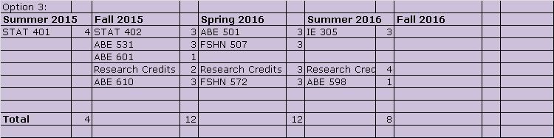

Suggested solution: Allow students to get off restricted enrollment when 10 or more graded credits as listed on the approved POS, are completed with 3.0 or better.

The root cause of this and the POS course issue, for which the 18 credit temporary dispensation was done, is the numbering of courses. The numbering issue should have been considered before changing policies dependent of on course numbering. There are a relatively few courses that are causing the majority of problems. It is not Grad Council business to determine how these problems are fixed, but we should insist that they are if policy changes based on numbering are to continue.

